

**PROJECT MANAGEMENT**

**IN-COURSE ASSESSMENT – GROUP ASSIGNMENT**

**CT050-3-3**

**Names:** BALRAM A/L KRISHNA KUMAR (TP035446)

MUHAMMAD IZZAT BIN MOHD JAMIL (TP035719)

ANG CHEE SIAH (TP038259)

YEO ZHI YIN (TP035402)

**Intake code:** UC3F1805CGD

**Module:** PROJECT MANAGEMENT (CT050-3-3)

**Lecturer’s Name:** MS. INTAN FARAHANA BT. KAMSIN

**Submission Date:** 12th SEPTEMBER 2018

**Word Count**: 14258 WORDS

# Acknowledgement

For this project, we would like to send our gratitude to the PRGMT module lecturer, Ms. Intan Farahana bt. Kamsin. While the delivery of the topic was not entirely on-the-spot with reference to the industrial standards, the basis on managing a project team is learnt nevertheless with the contents being sufficient for delivering this assessment’s output.

Secondly, we would like to thank the fellow classmates of the UC3F1805 intake. Despite the intake being a huge class and the interaction being not as frequent compared to the other module’s classes, everyone was supportive enough to aid with deeper understanding of the module’s content. While admittedly, we were not deserved of such huge of a support, we would like to thank their contribution on further improving this assessment’s output nevertheless, and we hope our assistance on their assessments would be proven enough help as well.

Lastly, we would like to thank our friends who were willing to give us our time to create this assessment output with response with our individual free time. This enabled us to successfully deliver a readable output for this module’s project. Their support on this assessment is well appreciated.

# Workload Matrix

|  |  |  |  |  |
| --- | --- | --- | --- | --- |
| *PROJECT MEMBERS* | **Balram A/L Krishna Kumar (TP035446)** | **Ang Chee Siah**  **(TP038259)** | **Muhammad Izzat Bin Mohd Jamil (TP035719)** | **Yeo Zhi Yin**  **(TP035402)** |
| **GROUP COMPONENTS** | | | | |
| **Project Methodology** | - | 100% | - | - |
| **Project Charter** | 25% | 25% | 25% | 25% |
| **Scope Statement** | - | - | - | 100% |
| **Issue Mapping** | 100% | - | - | - |
| **Gantt Chart & Network Diagram** | - | - | 100% | - |
| **Cost Budgeting** | - | - | - | 100% |
| **Quality Management** | - | 100% | - | - |
| **Cutover Strategy and Transition Plan** | - | 100% | - | - |
| **INDIVIDUAL COMPONENTS** | | | | |
| **Human Resource Management** | - | - | 100% | - |
| **Procurement Management** | 100% | - | - | - |
| **Communication Management** | - | 100% | - | - |
| **Risk Management** | - | - | - | 100% |
| **SIGNATURE** |  |  |  |  |

Table of Contents

Acknowledgement i

Workload Matrix ii

1. INTRODUCTION 1

Project Methodology Definition 1

Selected Project Methodology 2

Methodology Implementation 3

Project Management Process 4

Knowledge Areas 6

2. PROJECT CHARTER 8

2.1 Background 8

2.2 Aim and Objectives 8

2.3 Scope 9

2.3.1 Product Deliverables 9

2.3.2 Project Scope 9

2.4 Constraints 9

2.5 Estimation Budget 9

2.6 Roles & Responsibilities 10

2.7 High Level Risks 11

2.8 Major Project Milestones 11

2.9 Critical Success Factors 12

2.10 Signature 12

3. WORK BREAKDOWN STRUCTURE 13

4. SCOPE STATEMENT 16

4.1 Project Scope Description 16

4.2 Acceptance Criteria 16

4.3 Project Deliverables 16

4.4 Project Exclusions 16

4.5 Project Constraints 16

4.6 Project Assumptions 16

5. TABLE OF ISSUES 17

6. GANTT CHART AND NETWORK DIAGRAM 23

6.1 Gantt Chart 23

6.2 Network Diagram 25

7. COST ESTIMATION AND BUDGETING 31

7.1 Task Cost Breakdown 31

7.2 Resources Cost Breakdown 31

8. QUALITY MANAGEMENT PLAN 32

8.1 Plan Quality Management 33

8.2 Perform Quality Assurance 35

8.3 Control Quality 37

9. CUTOVER STRATEGY AND TRANSITION PLAN 38

9.1 Definition 38

9.2 Types of Cutover Strategy 38

9.3 Selected Cutover Strategy 41

10. LESSON LEARNED REPORT 42

10.1 Human Resource Management **[Muhammad Izzat Bin Mohd Jamil, TP035719]** 43

10.2 Procurement Management **[Balram A/L Krishna Kumar, TP035446]** 62

10.3 Communication Management **[Ang Chee Siah, TP038259]** 73

10.4 Risk Management **[Yeo Zhi Yin, TP035402]** 90

References 98

# 1. INTRODUCTION

## Project Methodology Definition

Project methodology is a necessary system that would be normally used when conducting a **project-based activity**, especially of those in a tremendously large scale. The system involves consideration of every aspect possible from skillsets, milestones to quality standards using various tools and techniques to create an efficient **working flow** for all individuals and departments in charge of the project developments, with the aim of **meeting the scope of project requirements**. The project usually requires the deliverables to be able to address any needs and concerns from all stakeholders.

Depending on the project’s content and workload, different types of methodology could be applied to suit the project best, but all of them ultimately ties to the following ‘ground rules’ (Cockburn, 2000):

* The **larger** a project is, the **larger** its **methodology** should be.
* More critical or important aspects of the project require **more attention** and ‘*publicly visible correctness in its construction’.*
* Any **small increase** in methodology size or density would **drastically increase** the project cost.
* **Face-to-face interaction** is the most effective communication method in conveying ideas and concepts.

## Selected Project Methodology

The project methodology applied to complete the project based on the case study scenario is the **Waterfall Model**. Waterfall model, at its core, is a **series of main phases** being arranged in a **sequential development model** (S. Balaji, 2012), as shown in the diagram in ***FIGURE 1.1***:

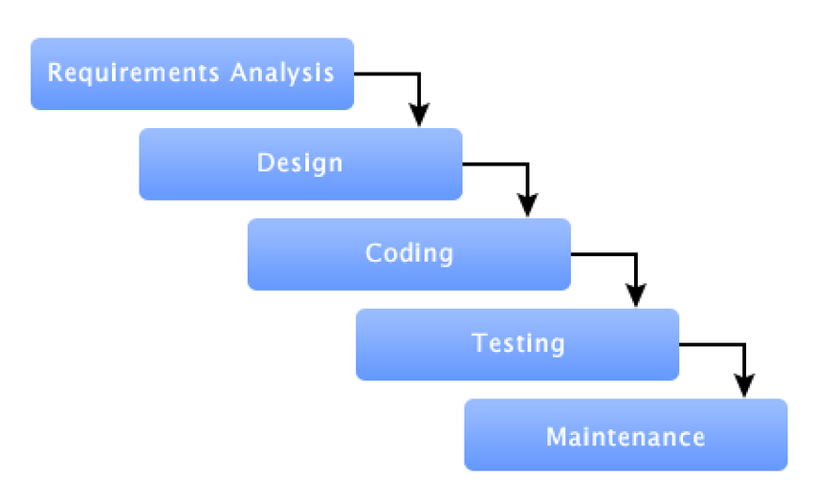

***FIGURE 1.1: Waterfall Model Basic Outline***

Waterfall model is an infamous development methodology for having the project scopes identified in advance, and having the project to **progress according the pre-defined phases** made from the identified scopes. In order to advance to certain phase, any phases before the said phase must be completed and verified.

Despite it being a rigid structure with low flexibly level, waterfall model is a nice methodology to refer with when working on similar **projects that has been attempted before**, or one that people has been familiar with its milestones entirely. The ISCMP, according to the case study, is a project where other countries such as China and Thailand have developed with years ago, and thus enabled a clear milestone reference in the current situation based on their attempts as well.

Also, due to the 4-month time restriction from the failure of previous management, the team would be in low levels of morale where most participants would lose motivation to continue with the project. Therefore, waterfall model would serve as a guideline for each participating unit so all of them would be **clear on their respective responsibilities in the shortest time possible**.

In exchange of low level of team coordination and synchronization, there is a **lower level of risk** of failing this project based on waterfall model, as conflicts between project teams and external organizations would be reduced to a minimum.

## Methodology Implementation

In this Integrated Supply Chain Management Project, the tasks would be divided into phases that would be formed into a hierarchy, where the priority of each project has been identified beforehand. Although creating a hand-written waterfall model as a project development guideline in this situation is applicable, the lack of time would make such process time-consuming for preparation alone.

Therefore, a suggestion of using the online-available software ***SpiraTeam***, where it provides a project overview, activities and lists of tasks along with risks in web application environment, which means the project model could be viewed and modified by using web-browser. The progress of each processes could be updated directly via such means, as shown in ***FIGURE 1.2***

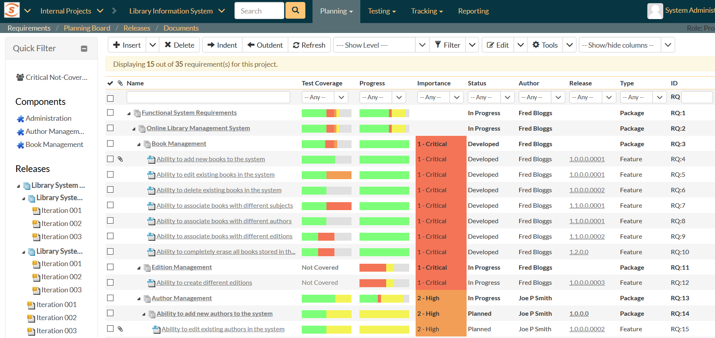

***FIGURE 1.2: SpiraTeam Waterfall Model Sample***

Based on the progress report, the coverage and priority level of each tasks could be identified easily among all departments and ensures an easier approach of follow-up to the waterfall model to complete the project.

## Project Management Process

The project management is divided into 5 phases according to their respective processes, which are **Initiating**, **Planning**, **Executing**, **Monitoring** **and** **Controlling**, and **Closing**.

1. **INITIATING**

In initiation process, the organization is required to **identify the project**, its content including objectives and phases. Once all elements of the project have been identified, the project will start on the Project Manager’s cue, in most situations.

The activities conducted in this phase normally involves **creating a project charter** to understand the key information and project specifics (Kerzner & Kerzner, 2017), while **identifying the stakeholders** of the project to determine everyone’s influence on the project’s development.

1. **PLANNING**

Planning is when the project is in the stage of writing a **guide for project executions**. All available resources would be accounted for to devise an efficient plan to complete the project and meet its requirements.

That includes the process of creating a proper **Work Breakdown Structure** (WBS), project **scope statements**, **project** **schedules** (usually in Gantt Chart format), and list of **potential risks** during the development (Kerzner & Kerzner, 2017).

1. **EXECUTING**

The project officially begins during the execution phase, where all units of the project development team are **producing the output of the project**. In the meantime, the project manager would take the role of coordinating all departments and resolve all challenges arose during the process.

While creating the **project deliverables** is usually the output from this process, **milestone reports** tend to be accompanied along with the output to ensure a brief description on the deliverables from each team during progress checking (Kerzner & Kerzner, 2017).

1. **MONITORING AND CONTROLLING**

While all the planned processes have been set in motion, the progress checking on those actions are vital to ensure the project not to be derailed via **correction actions**.

Several changes in requests or updates might occur while creating project deliverables, and thus **performance reports** and **update requests** are essential as output from this process (Kerzner & Kerzner, 2017).

1. **CLOSING**

When all the processes have been completed and corrected, the **project output would be delivered to all stakeholders** and/or potential consumers to review the product, provide feedback, and determine if the output is suitable for public release.

Regardless of the acceptance of the project deliverables, this process should produce a **completed project documentation**, **self-reflection reports** and relevant **presentation aids** as a wrap-up of a project being closed entirely (Kerzner & Kerzner, 2017).

## Knowledge Areas

The applicable knowledge areas regarding the project management on this assessment includes the following elements:

1. **Project Integration Management**

Project integration is a segment where any changes that occur during the project’s life cycle must be identified, evaluated and resolved by **coordinating all knowledge areas involved** in it (Fuller, et al., 2017).

1. **Project Scope Management**

In scope management, all objectives required by the project are determined and **devise required deliverables of the project** to ensure the process successfully addresses all the work needed for it (Fuller, et al., 2017).

1. **Project Time Management**

As the title suggests, time management is a section that deals with estimating time needed to complete the project, it’s relevant processes and create a **working schedule** that could utilize all departments in project development (Fuller, et al., 2017).

1. **Project Cost Management**

Like time management, cost management estimates the capital the project has been allocated to and determines the suitable **amount of budget** allocated to each department to ensure a smooth workflow of each processes (Fuller, et al., 2017).

1. **Project Quality Management**

While all the processes in a project must be completed within allocated periods, quality management is necessary to **make sure the deliverables from every processes meet its requirements** that was from the scope management segment (Fuller, et al., 2017).

1. **Project Human Resource Management**

**Allocating people to their respective roles** in project development comes into the responsibility of the human resource management, where each participating individuals’ skillsets and interests are analyzed to make sure highest level of efficiency could be achieved from the process (Fuller, et al., 2017).

1. **Project Communication Management**

Planning, managing and controlling the communications within the project teams is a vital aspect in managing a smooth development flow, where **project information can be collected, stored, and relayed** to desired departments in an appropriate and timely manner (Fuller, et al., 2017).

1. **Project Risk Management**

While meeting the project scopes, the risk management is a segment that is normally in charge of **identifying and analyzing the potential risks** that might occur to the project development, while respond and **resolve it immediately** when one happens in the process of project execution (Fuller, et al., 2017).

1. **Project Procurement Management**

In several occasions, procurement management is necessary to **acquire goods and services from outside of the project team or organization**, usually with aim of integrating the goods and services into the project development to increase the quality of the project deliverables or reducing the cost of creating one from scratch (Fuller, et al., 2017).

# 2. PROJECT CHARTER

## 2.1 Background

In this scenario, we were assumed the role as project management team from a company named *Good Life Pte. Ltd. (GL),* with the project entitled **‘Integrated Supply Chain Management Project’ (ISCMP)**.

ISCMP is a project aimed to **enhance supply chain operations**. Therefore, ISCMP features **a Supply Chain Management (SCM) software** supported by a centralized data warehouse to manage all users’ respective region’s inventory in a faster pace. While the created system has business intelligence capable of **inventory** management for markets in South East Asia region, the system also covers **transportation** management, **order** management, **yard** management, **labor** management, and **warehouse** optimization.

While the project was scheduled to be completed in 6 months, the previous project manager’s attempt on the project for the first 2 months could be summarized as ‘failure’. Therefore, we as a new management team were instructed to **complete the ISCMP in the next 4 months**, while resolving all issues that arose from the previous management.

## 2.2 Aim and Objectives

**AIM**

To implement a centralized data warehouse that can provide business intelligence services, which allow users to make optimum decisions in their regional inventory management.

**OBJECTIVES**

* Enable production entry by removing raw materials and automatically updating finished goods in the accounting system.
* Able to anticipate the product demand by the amount of item recorded in warehouse, customer sales and other relevant aspects.
* Calculation of manufacturing costs from raw material to labor cost for cost analysis.
* Enable documentation of required raw materials, created product, and labor amount for production
* Include automated demand planning where what materials are needed to be ordered and what products are needed for higher production rate based on anticipated demand
* All market users in the South East Asia region can manage inventory, order, yard, and labor information from a centralized data warehouse.

## 2.3 Scope

### 2.3.1 Product Deliverables

* Inventory management system
* Product management system
* Order management system
* Yard management system
* Labor management system
* Warehouse optimization system

### 2.3.2 Project Scope

* Complete a supply chain management system that is integrated for users in South East Asia markets
* The management system must contain common functions of a typical supply chain management software.

## 2.4 Constraints

1. Some of the budget was used in the first 2 months, and therefore the leftover budget is limited for the recovery effort
2. The deadline is set to 4 months later, which is a time constraint from the previous 2 months being non-productive
3. The project is currently deemed a failure from the feedback report
4. Several required software development skills were lacking
5. The information of the project stakeholders remains unknown

## 2.5 Estimation Budget

|  |  |
| --- | --- |
| **Estimated Budget** | **$280,000.00** |
| Hardware | $50,000.00 |
| Development Software | $80,000.00 |
| Manpower | $100,000.00 |
| **RESERVE** | **$50,000.00** |

## 2.6 Roles & Responsibilities

| **Role** | **Source / SME-Department** | **Responsibility** |
| --- | --- | --- |
| Project Manager | Internal (GITS – Project Management Centre/PMAC) | * Prepare project management plan and revision(s) as deliverables * Define Project Scope, Aim & Objectives |
| Project Sponsor | Internal (GITS) | * Approving key project deliverables * Initiating and participating in project reviews and providing directions |
| Project Manager Advisor | Internal (GITS – Project Management Centre/PMAC) | * Assist Project Manager in determining the essential plans required for the project * Relay necessary information regarding project updates and changes |
| Software Engineer | Internal (GITS – Application Development Centre/ADC; Data Center Operations/DCO) | * Develop the core mechanics of the software * Fulfil the software requirements as stated in Product Deliverables that could function normally. |
| UI Designer | Internal (GITS – Application Development Centre/ADC) | * Create a user-friendly user interface for the system’s controls |
| Software Tester | External (Market – Human Resources Dept/HR) | * Test-running the software prototype * Uncover bugs from testing and submit relevant reports to the software development teams. |
| Quality Control Manager | Internal (GITS – IT Operations/ITO) | * Compile feedbacks from software tests and generate feedback & improvement report to software developers |
| Technical Assistant | Internal (GITS – IT Security) | * Resolve all errors occurred in the development software and hardware that could prolong the development process |
| Communication Officer | External (Market – Procurement/PROC) | * Contact potential project sponsors for assistance in project development. |
| Procurement Officer | External (Market – Procurement/PROC) | * Identify potential sponsors as stakeholders * Audit available resources of procurement from project sponsors |

## 2.7 High Level Risks

Several high-level risks have been identified for the project to be successful, including:

* Failure of uniform communication means between departments of project.
* Missing of a proper organizational structure that could clearly divide the development team to their respective ‘specialty tasks’.
* Severe lack in specific areas of software development, the network and security section among the areas in question.

## 2.8 Major Project Milestones

|  |  |
| --- | --- |
| **Milestones** | **Date** |
| Start Project | 11/6/2018 |
| Receive Project Approval | 19/6/2018 |
| Complete Planning Phase | 13/7/2018 |
| Complete ISCMP Requirements | 24/7/2018 |
| Complete ISCMP Development | 20/9/2018 |
| Complete Testing | 9/10/2018 |
| ISCMP Installation | 15/10/2018 |
| Functional ICSMP | 22/10/2018 |
| Project End | 30/10/2018 |

## 2.9 Critical Success Factors

Several success criteria have been identified as critical success factors that would lead to effective completion of the project, in which include:

1. Complete the project within the allocated budget of $280,000.00 with no budget overruns.
2. Efficient usage of capable resources would be selected from the SME-departments as within the organization structure of **Good Life Pte. Ltd.** and **Global IT**.
3. The created system must be able to be supported by current IT infrastructure.
4. It is mandatory for related departments in Global IT Service to provide approval and signoff for system implementation
5. All support staff and users must have access to the developed system with relevant Access Level (ACL) privileges
6. The current system must be replaced in phases by ISCMP.
7. The cutover and transition from the current system with the newly developed system must be in **parallel**

## 2.10 Signature

|  |  |  |  |
| --- | --- | --- | --- |
| **SIGNATURE** | | | |
|  |  |  |  |
| Good Life Pte. Ltd.  Company Executive Officer | Project Manager | Project Manager Advisor | Project Sponsor |

# 3. WORK BREAKDOWN STRUCTURE

|  |
| --- |
| **Integrated Supply Chain Management Project (ISCMP)** |
| **1 Initiating** |
| **1.1 Identify Stakeholders** |
| **1.2 System Proposal** |
| **1.3 Feasibility Studies** |
| 1.3.1 Technical Feasibility Study |
| 1.3.2 Schedule Feasibility Study |
| 1.3.3 Financial Feasibility Study |
| 1.3.4 Resource Feasibility Study |
| **1.4 Develop Project Charter** |
| 1.4.1 Determine Project Aim & Objectives |
| 1.4.2 Determine Project Scope |
| 1.4.3 Determine Project Budget |
| 1.4.4 Determine Project Roles |
| 1.4.5 Determine Project Risks |
| 1.4.6 Determine Project Milestones |
| **2 Planning** |
| **2.1 Develop Project Plan** |
| 2.1.1 Identify Phases & Activities |
| 2.1.2 Create Project Planning Schedule |
| **2.2 Develop Resource Plan** |
| 2.2.1 Identify Types of Tasks |
| 2.2.2 Identify Number of Staff |
| 2.2.3 Identify Needed Equipment |
| 2.2.4 Identify Equipment Types & Quantity |
| **2.3 Develop Financial Plan** |
| 2.3.1 Identify Labour Costs |
| 2.3.2 Identify Equipment Costs |
| 2.3.3 Identify Miscellaneous Costs |
| **2.4 Develop Quality Plan** |
| 2.4.1 Identify Customers Requirements |
| 2.4.2 List Project Deliverables |
| 2.4.3 Define Quality Standards for Deliverables |
| 2.4.4 Customer Approval for Set Targets |
| **2.5 Develop Risk Plan** |
| 2.5.1 Identify Project Risks |
| 2.5.2 Categorize & Prioritize Risks |
| **2.6 Develop Communication Plan** |
| 2.6.1 List Communications Stakeholders |
| 2.6.2 Define Communication Needs |
| **2.7 Develop Procurement Plan** |
| 2.7.1 Determine Procurement Requirements |
| 2.7.2 Identify Needed Procurement |
| 2.7.3 Create Financial Justification |
| **3 Execution** |
| **3.1 Requirement Gathering** |
| 3.1.1 Client Interview |
| 3.1.2 Construct Use Case |
| 3.1.3 Prototyping |
| **3.2 Procurement** |
| 3.2.1 Compare Supplier Prices |
| 3.2.2 Negotiate Prices |
| 3.2.3 Obtain Hardware |
| 3.2.4 Obtain Software |
| **3.3 Staff Management** |
| 3.3.1 Recruits Interview |
| 3.3.2 Allocate Human Resources |
| 3.3.3 Labour Tracking |
| 3.3.4 Training Tracking |
| 3.3.5 Time Tracking |
| **3.4 Development** |
| 3.4.1 Functional Development |
| 3.4.2 Technical Development |
| 3.4.3 Application Development |
| **3.5 Testing** |
| 3.5.1 Application Development Centre Testing |
| 3.5.2 IT Regression Testing |
| 3.4.3 User Acceptance Testing |
| **3.6 System Setup** |
| 3.6.1 Hardware Installation |
| 3.6.2 System Installation |
| **4 Monitoring & Controlling** |
| **4.1 HR Management** |
| 4.1.1 Control Man Days |
| 4.1.2 Monitor Staff Progress |
| **4.2 Procurement Management** |
| 4.2.1 Quantity Control |
| 4.2.2 Quality Control |
| **4.3 Quality Deliverables** |
| 4.3.1 Testing Reports |
| **5 Closing** |
| **5.1 Documentation** |
| 5.1.1 Procurement Report |
| 5.1.2 Financial Report |
| 5.1.3 Project Documentation |
| 5.1.4 Stakeholders Approval & Signature |
| **5.2 Formal Acceptance & Information** |
| 5.2.1 Inform Stakeholders |
| 5.2.2 Stakeholders Approval & Signature |
| 5.2.3 End Staff Employment |
| 5.2.4 End Supplier Contract |

# 4. SCOPE STATEMENT

## 4.1 Project Scope Description

The scope of this project is to restore the order and maintain morale of the developing team and make sure the product is produced with quality within deadline.

## 4.2 Acceptance Criteria

The conditions of the acceptance criteria are that the system should be able to provide the common functions that can be found in typical SCM software, supported by centralized data warehouse log which provides business intelligence capacities for user to make quicker decision in managing such as inventory managing. The system should be covering features like transportation management, yard management, labor management and warehouse optimization.

## 4.3 Project Deliverables

The end product of this project would be a software designed specialized for Supply Chain Management. The end product provides the common functions that can be found in any SCM. Other than that, the system is also supported by a huge centralized data warehouse which provides business intelligence capabilities in facilitating users to make quicker decision in managing inventory in their own region. The system also covers transportation management, order management, yard management, labor management and warehouse optimization.

## 4.4 Project Exclusions

Stakeholders can expect a completed bug-free software by the end of the project period, excluding:

1. Lack of advanced security services on database protection.
2. Capped logs duration.
3. System access limited to high-ranked staffs only.
4. Lack of multi-language support to non-English users

## 4.5 Project Constraints

* **Time frames**: The project need to be done with 4 months left.
* **Resources**: The hardware technical specifications are not up to date.
* **Activity performance**: Team members are focusing more on their daily operation support rather than task assigned.

## 4.6 Project Assumptions

* The project team might need an experienced advisor to advise the project manager on leadership and interpersonal skills.
* Better hardware might be needed to speed up developing progress.
* Time management might need to be implemented to manage the efficiency of the team members.

# 5. TABLE OF ISSUES

|  |  |  |  |
| --- | --- | --- | --- |
| **Integration Management** | | | |
| **Issue No.** | **Issues** | **Project Management Process** | **Tools & Technique** |
| 4 | The PC and server hardware technical specifications were constantly being changed to suit new or added requirements. | Planning | **Expert Judgement**:  Get the latest and most powerful hardware technical specifications so the requirement to go for higher specifications would be very small change. |
| 5 | Requirements keep coming in from users almost daily where the GITS-ADC Team Lead keeps on accepting them without hesitation. | Execution | **Negotiations**:  Keep the requirements update monthly and inform the Team Lead to not take requirements when the team is already full of work. |
| 15 | Technical skills were especially lacking in the network and security areas. | Planning | **Group Decision-Making Techniques**:  Hiring a professional technical team to ensure all technical problems to assist with. |

|  |  |  |  |  |
| --- | --- | --- | --- | --- |
| **Human Resource Management** | | | | |
| **Issue No.** | **Issues** | **Project Management Process** | **Tools & Technique** |
| 6 | There was redundancy of work performed as the Work Breakdown Structure (WBS) was done separately by each respective department and the Project Manager did not review and then consolidate those WBSs into one wholistic WBS | Initiation | **Pre-Assignment**:  Assigning teammates to work on tasks following the WBS and provide regular updates to the project manager. |
| 7 | Most of the team members have been focusing more on their daily operation support rather than tasks being assigned by the Project Manager or their respective Team Lead | Execution | **Performance Reviews**:  Conduct a daily check routine to ensure the project plan is being followed and ensure the team members are doing their task as provided. |
| 13 | There was no clear project organizational structure to manage the project. | Planning | **Organization Chart**:  With organization chart, clear organizational structure is developed start from the highest management till the individual responsibility. |

|  |  |  |  |
| --- | --- | --- | --- |
| **Communication Management** | | | |
| **Issue No.** | **Issues** | **Project Management Process** | **Tools & Technique** |
| 1 | The steering committee (which consist of the board of directors, CEO and Senior Managers of the organization) do not recall of being presented the project feasibility study by the Project Sponsor or the Project Manager to them. | Initiation | **Communication Requirement Analysis**:  Determine all stakeholders means of communications, calling intervals and recommended timing plus the duration |
| 6 | There was redundancy of work performed as the Work Breakdown Structure (WBS) was done separately by each respective department and the Project Manager did not review and then consolidate those WBSs into one wholistic WBS | Initiation;  Planning | **Meetings**:  Gathers the stakeholders for a face to face deliver more on the working requirements for a complete and centralized WBS.  **Issue Logs**:  Identify all issues that the project has and delegate manpower easier based on the problem-solving strategies’ comparison |
| 7 | Most of the team members have been focusing more on their daily operation support rather than tasks being assigned by the Project Manager or their respective Team Lead | Execution | **Performance Reporting**:  Conduct a daily-to-monthly check routine to ensure the project plan is being followed and ensure the team members are doing their task as provided. |

|  |  |  |  |  |
| --- | --- | --- | --- | --- |
| **Risk Management** | | | | |
| **Issue No.** | **Issues** | **Project Management Process** | **Tools & Technique** |
| 11 | The testing plan was not developed yet | Planning | **Benchmarking**:  Pre-plan for 2 types of testing such as white-box testing and black-box testing. Also have phases on test on such as alpha phase, beta phase and so on. |
| 12 | There was not even a clear designated sponsor (or sponsors) for the project. | Planning | **Communication Technology**:  Ensure the stakeholders for the project before the project starts. |
| 15 | Technical skills were especially lacking in the network and security areas. | Planning | **Group Decision-Making Techniques**:  Hiring a professional technical team to ensure all technical problems to assist with. |

|  |  |  |  |  |
| --- | --- | --- | --- | --- |
| **Time Management** | | | | |
| **Issue No.** | **Issues** | **Project Management Process** | **Tools & Technique** |
| 8 | Tasks are performed without prioritizing other dependent tasks. | Monitoring & Controlling | **Meetings**:  Perform constant checking on employees and keep up with the progress for all department head managers. |
| 15 | Technical skills were especially lacking in the network and security areas. | Planning | **Group Decision-Making Techniques**:  Hiring a professional technical team to ensure all technical problems to assist with. |
| 18 | The hardware and software delivery were still being negotiated with some potential vendors while there were only four (4) months to complete the project. | Planning | **Resource Optimization Techniques**:  Without any delay, employees are to start work with what they have |

|  |  |  |  |  |
| --- | --- | --- | --- | --- |
| **Procurement Management** | | | | |
| **Issue No.** | **Issues** | **Project Management Process** | **Tools & Technique** |
| 9 | IT assets acquisition and spending were through PROC Manager with suppliers without going through a proper tendering process. | Execution | **Inspections and Audits**:  Having inspections and audits to confirm supplies from suppliers. |
| 10 | Purchasing of IT assets without a proper tendering process has led to overrun by budget. | Planning | **Expert Judgement**:  Get the latest and most powerful hardware technical specifications so the requirement to go for higher specifications would be very small change. |
| 18 | The hardware and software delivery were still being negotiated with some potential vendors while there were only four (4) months to complete the project. | Planning | **Performance Reporting**:  Performance updates need to be provided to the project manager, the project manager will be able to handle the issues and updates needed to be provided to the stakeholders and the suppliers for the supplies. |

|  |  |  |  |  |
| --- | --- | --- | --- | --- |
| **Quality Management** | | | | |
| **Issue No.** | **Issues** | **Project Management Process** | **Tools & Technique** |
| 9 | IT assets acquisition and spending were through PROC Manager with suppliers without going through a proper tendering process. | Execution | **Process Analysis**:  Conduct testing and checking the status to ensure the quality is top-notch. |
| 15 | Technical skills were especially lacking in the network and security areas. | Planning | **Group Decision-Making Techniques**:  Hiring a professional technical team to ensure all technical problems to assist with. |
| 18 | The hardware and software delivery were still being negotiated with some potential vendors while there were only four (4) months to complete the project. | Planning | **Design of Experiment**:  Testing is expected in the process, thus planning out the hardware and software that would be of use. |

|  |  |  |  |  |
| --- | --- | --- | --- | --- |
| **Scope Management** | | | | |
| **Issue No.** | **Issues** | **Project Management Process** | **Tools & Technique** |
| 2 | The project approval was not formally documented. | Initiation | **Alternatives Identifications**:  Use multiple ways to confirm all approval and document them in hard copy as well as soft copy. |
| 3 | There is no evidence that a proper project management process was followed. | Initiation | **Inspection**:  Check all department and confirm all with evidence. Double confirm them if necessary. |
| 14 | The Project Manager’s authority was constantly overridden by the department head managers. | Controlling & Monitoring | **Variance Analysis**:  Keep all the department head managers under control, as well as keep them under monitor if there were anything wrong to happen. |

# 6. GANTT CHART AND NETWORK DIAGRAM

## 6.1 Gantt Chart









## 6.2 Network Diagram

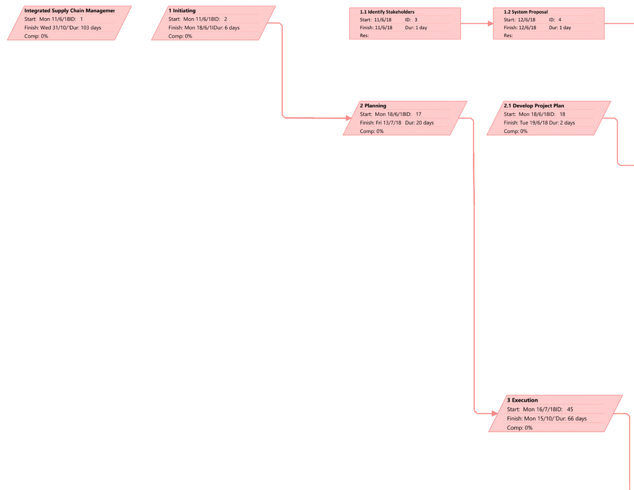

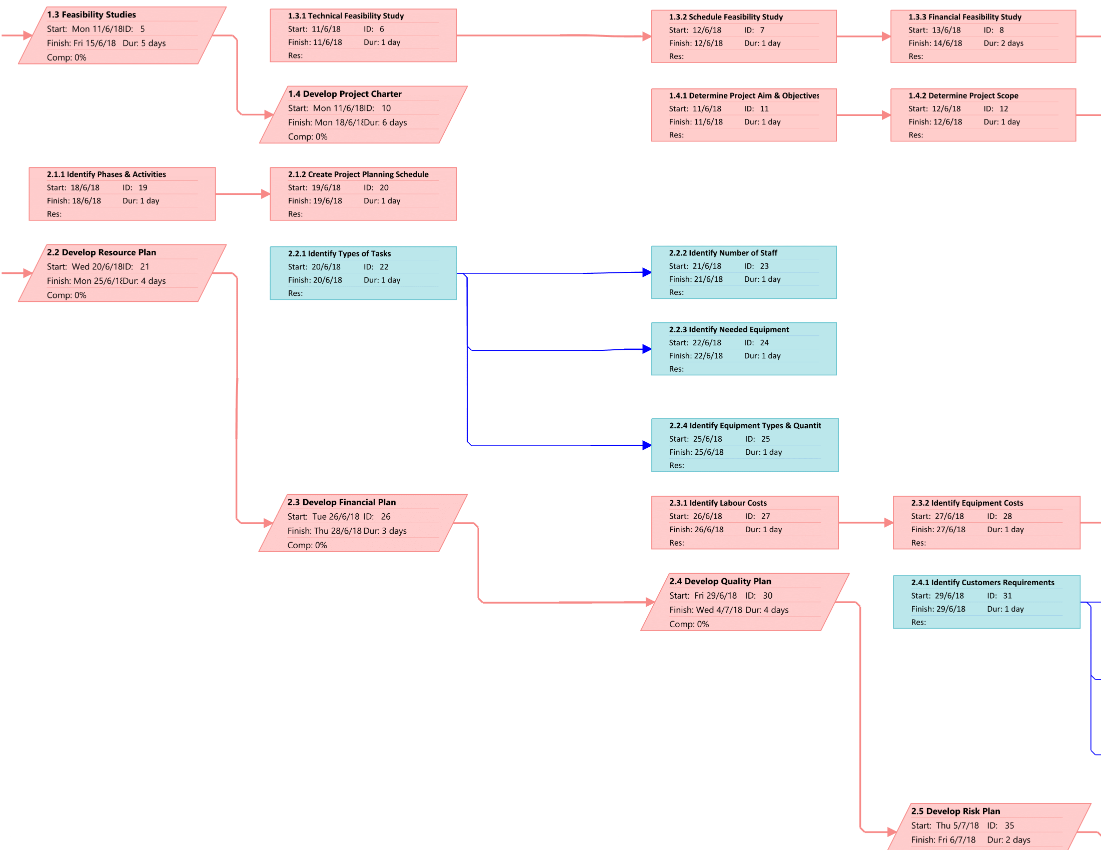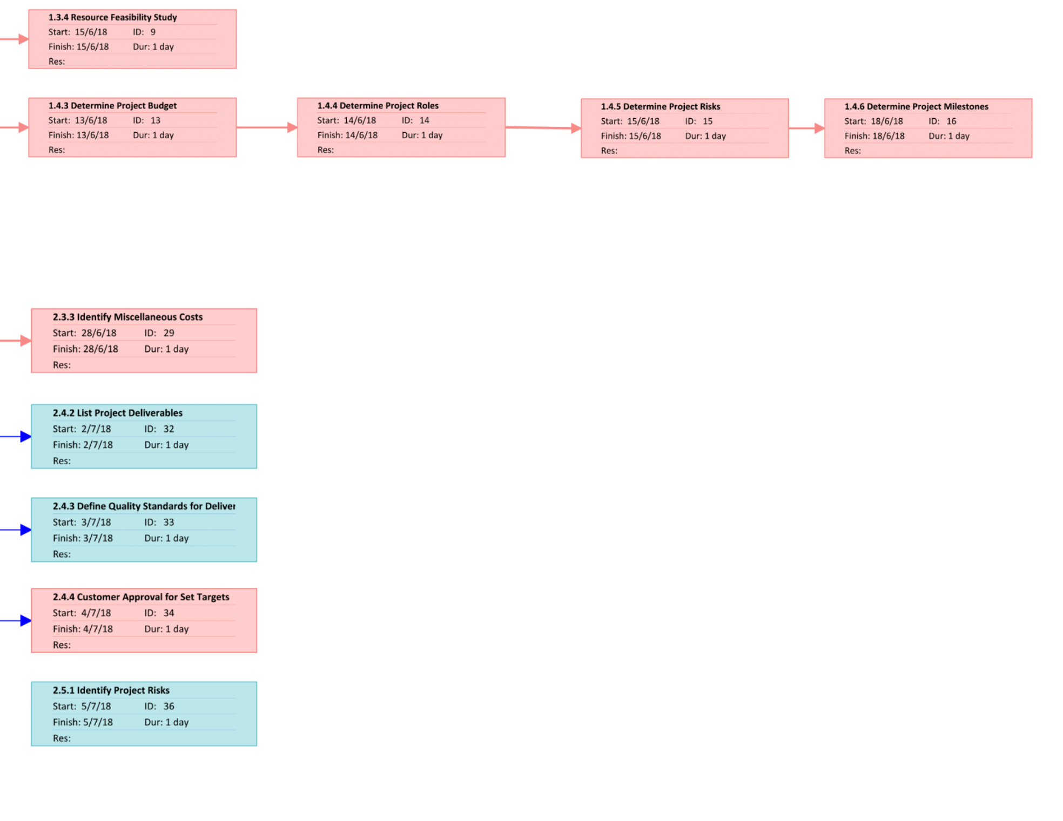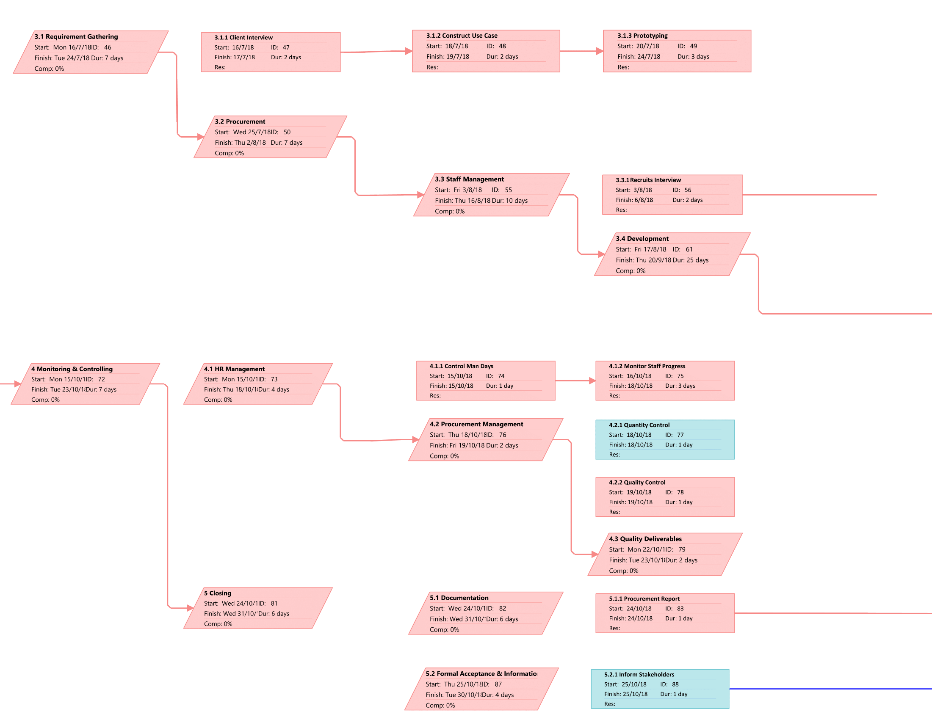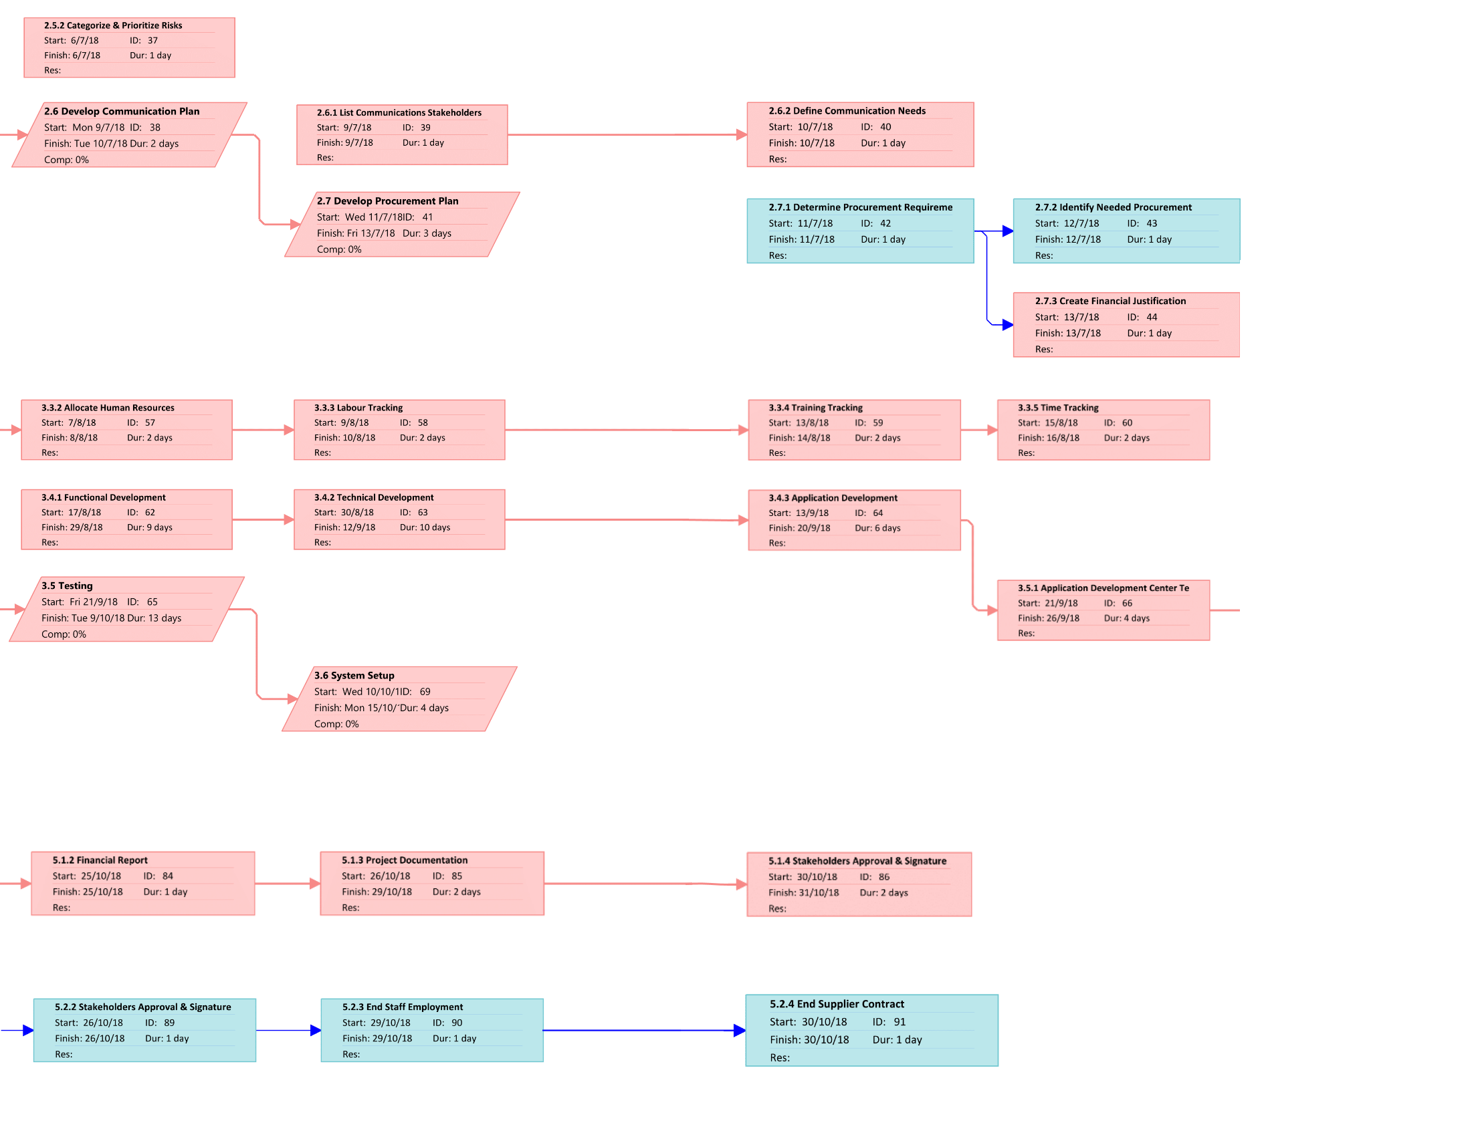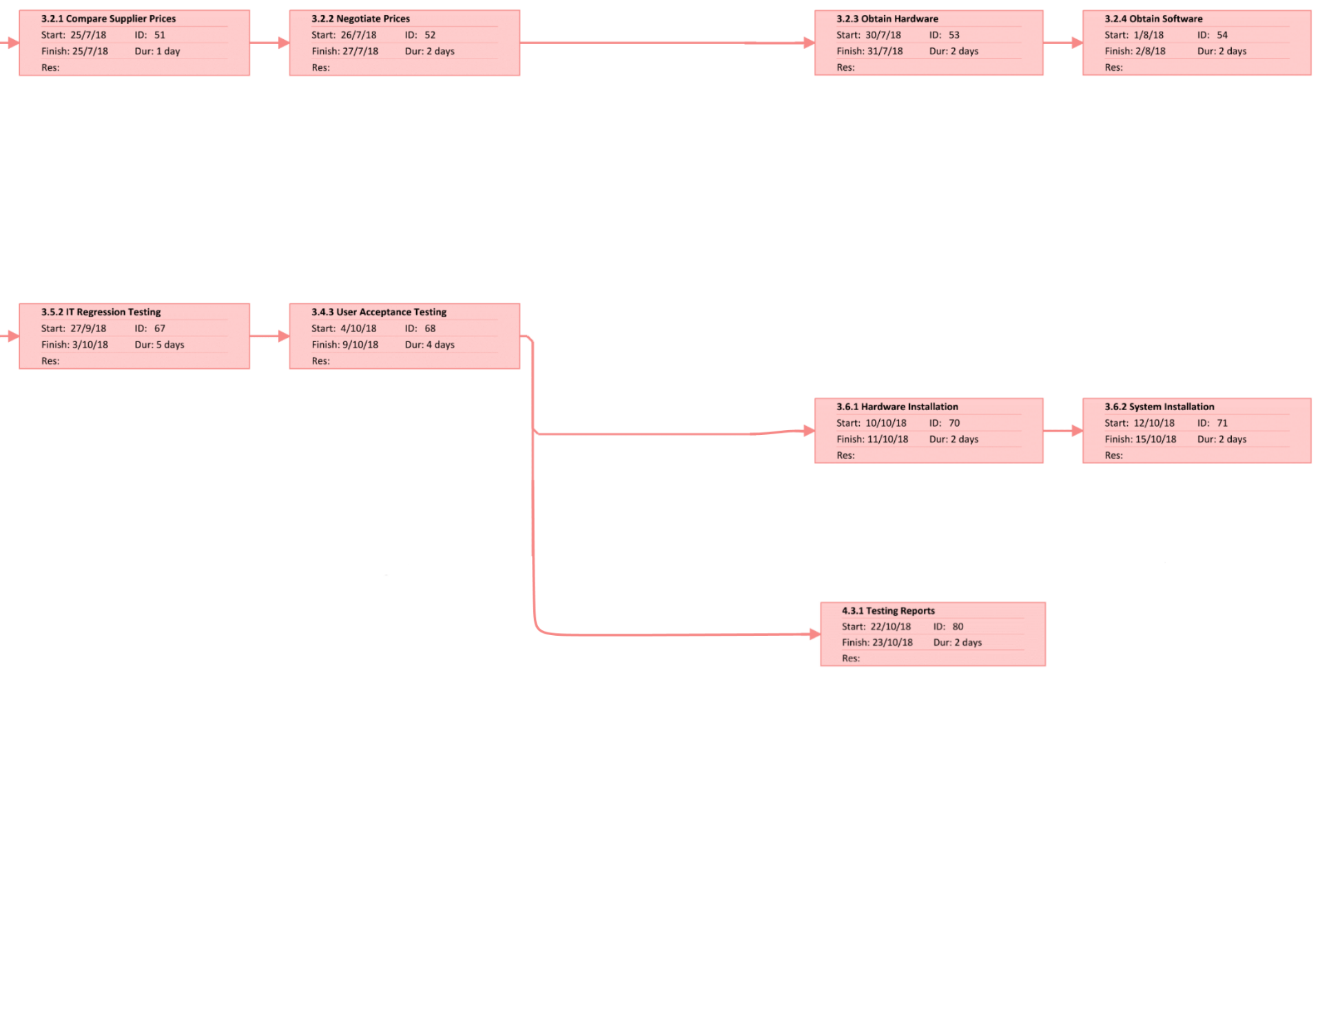

# 7. COST ESTIMATION AND BUDGETING

## 7.1 Task Cost Breakdown

## 7.2 Resources Cost Breakdown

|  |  |  |  |  |  |
| --- | --- | --- | --- | --- | --- |
| **Resource Name** | **Amount** | **Std. Rate** | **Working Duration** | **Calculation** | **Cost** |
| Project Manager | 1 | $3000/mon | 4 Months | 7000 x 4 | $28,000 |
| Software Engineer | 3 | $2200/mon | 4 Months | 2200 x 4 x 3 | $26,400 |
| UI Designer | 1 | $1800/mon | 4 Months | 1800 x 4 | $7,200 |
| Software Tester | 1 | $1000/mon | 1 Month | 1000 | $1,000 |
| Quality Control | 1 | $1700/mon | 4 Months | 1700 x 4 | $6,800 |
| IT Security | 1 | $1800/mon | 4 Months | 1800 x 4 | $7,200 |
| Technical Assistant | 1 | $1800/mon | 4 Months | 1800 x 4 | $7,200 |
|  |  |  |  | **Total:** | **$83,800** |

# 8. QUALITY MANAGEMENT PLAN

Quality management is an element that was introduced since the early stages of project management’s definition, sharing the same status as cost and time (Atkinson, 1999). It is an important aspect in project management where the performance of the product – the Integrated Supply Chain Management System in this scenario – is matching the required quality as mentioned in the project’s scope. For ensuring the quality of the product in development, actions and policies would be undertaken in form of three major processes:

* **Plan Quality Management**;
* **Performing Quality Assurance**; and
* **Performing Quality Control**

And in those three processes, some tools and techniques would be applicable in managing the project’s output quality, where it includes quality metrics, checklists, Pareto Charts, quality control charts, fishbone diagrams, maturity models and many others (Marchewka, 2014).

**Issues Involved**

|  |  |  |  |  |
| --- | --- | --- | --- | --- |
| **Quality Management** | | | | |
| **Issue No.** | **Issues** | **Project Management Process** | **Tools & Technique** |
| 9 | IT assets acquisition and spending were through PROC Manager with suppliers without going through a proper tendering process. | Execution | **Process Analysis**:  Conduct testing and checking the status to ensure the quality is top-notch. |
| 15 | Technical skills were especially lacking in the network and security areas. | Planning | **Group Decision-Making Techniques**:  Hiring a professional technical team to ensure all technical problems to assist with. |
| 18 | The hardware and software delivery were still being negotiated with some potential vendors while there were only four (4) months to complete the project. | Planning | **Design of Experiment**:  Testing is expected in the process, thus planning out the hardware and software that would be of use. |

## 8.1 Plan Quality Management

Planning would be the focus of this process. The content of planning includes **identifying which quality standards** are relevant to the project, and **methods required** to meet those standards. This is done to anticipate situations and prepare appropriate actions to bring out the needed outcome.

To devise a plan to an overall quality management, it is required to have a project management plan, stakeholder register, environmental factors and other available assets to deliver not only a **quality management plan**, but also **quality metrics**, **checklists** and relevant **updates to the project’s documentation** such as process improvement plan (Kima, et al., 2012).

While producing the deliverables, several tools and techniques could be adapted, in which **cost-benefit analysis** would be among the main methods to determine the capital required to create a system with high enough performance. Since the system in question has already developed by other regions, **benchmarking** techniques are applicable to compare for most suitable practices such as the database design (Cooper, et al., 2010). **Design of experiments** technique is also applicable to produce list of factors for the product in development (Gyung-Jin, 2007).

To solve **ISSUE NO. 18** where despite of the lack of time, negotiations with hardware and software delivery for the project is still undergoing, the **design of experiments** technique would assist in resolving the issue. In design of experiments, the 3 components of the project include *Factors*, *Levels* and *Response* as per illustrated in ***FIGURE 8.1.1***:

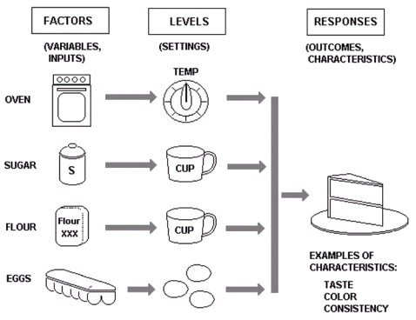

***FIGURE 8.1.1: Components of Design of Experiments (Example: Baking a Cake)***

For typical experiment designs, *Factors* would be inputs for the process; *Levels* being the weight and value set to each factor; and *Responses* being its output. While for the case in **ISSUE NO. 18**, the components in the design of experiments would be as follows:

* *Factor(s)*: Hardware & Software
* *Level(s)*: Performance (Hardware & Software); Price (Hardware & Software)
* *Response(s)*: Quality of Product (Integrated Supply Chain Management Software)

Based on the layout of the design of experiments, it could be found that the hardware and software used to develop the Integrated Supply Chain Management Software would be the main factor affecting the output, while their respective performance and price would be weighed.

To conduct a proper comparison for this experiment of *‘comparing hardware and software performance relative to pricing in ISCMP’*, a template should be made to collect each target’s data, as displayed in ***FIGURE 8.1.2***.

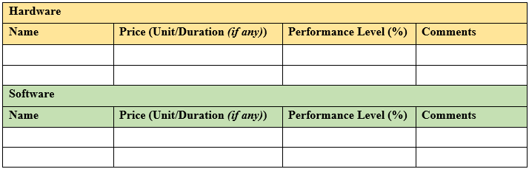

***FIGURE 8.1.2: Template of Hardware & Software Comparison for ISCMP***

While the names of each hardware and software are necessary, the **price** of these development assets would be considered by the price per duration, if any is mentioned. For example, the price of a Cloud subscription to Visual Studio Enterprise on monthly basis would take *$250/Month*. The **performance level** would determine how useful would it be in form of percentages. In this case, the performance of Visual Studio Enterprise would be considered 80% since most software developers would be using the system for coding the core mechanics. **Comments** serves more as a post script to mention any additional information regarding the target’s pricing or performance level. Using Visual Studio Enterprise as example, the comments may include ‘*inclusion of Azure Cloud service to share codes and track workloads’*.

## 8.2 Perform Quality Assurance

As the project is progressing, quality assurance is required to be performed to ensure all processes of the project can meet the relevant quality standards, in the meantime able to **achieve continuous quality improvement besides satisfying the minimum requirements** (Wandersman, et al., 2012).

While this process requires the input of most outputs from the planning process of quality management such as the quality management plan, process improvement plan and quality metrics, the process should be able to deliver a complete list of **change requests**, **updates on project management plan and its documentation**, including required **improvements on the available assets** (Taylor, 2018).

The deliverables of this process could be created with **quality management and control tools** like from the planning phase, such as leaning and benchmarking to maximizing output efficiency and minimizing waste, while ensure a compete-able quality with potential competitors (Larson & Gray, 2013). **Quality audits** are necessary too to measure how well is the monitoring of the project development matches the standard as per the project requested, identifying any lessons learned that could further improve the project’s output (Taylor, 2018). In the same time, **process analysis** would be conducted to examine the development processes so that in case of sidetracking, the processes could be tailored to align with the project requirements (Vergidis, et al., 2008).

To solve **ISSUE NO. 9** where the spending of IT assets passed through Procurement Management (PROC) without any tendering processes carried out. For solving this issue, the **process analysis** technique could be applied to create the tendering process. From this technique, the tendering process could be classified into several steps, in following order:

1. **Determine Tendering Types**
   * Selecting preferred format of tendering process such as:
     1. *Open Tendering*: Tender by public advertisements
     2. *Select Tendering*: Tenders selected via shortlisting from open tender(s)
     3. *Multi-stage Tendering*: Compare tenders from multiple stages featuring specific requirements
2. **Prepare Request for Tendering**
   * Prepare invitations to suppliers for competitive offer to win contract with ISCMP:
   * Must include description of the procured products; conditions to tender; relevant evaluation criteria, required submission content and format.
3. **Inviting Tenders**
   * Identify potential tenders who would likely respond to invitation
   * Contact project team regularly to find any future tender opportunities
4. **Response from Suppliers**
   * Receive all required documents from the suppliers
   * Hosting pre-tender briefing sessions to clarify any uncertainties
5. **Evaluation & Selection**
   * Check for compliance of each tender based on the evaluation criteria
   * Select tender(s) meeting the mandatory and technical requirements
6. **Notification & Debriefing**
   * Advice session for winning tenderer & debriefing
7. **Establish & Manage Contracts**
   * Form formal agreements between project team and the tenderer

According to the process analysis, there would be 7 steps where the PROC should follow to devise a proper tendering process to ensure all potential suppliers would be able to follow through the details the project team required tenderers to understand, while managing the standards of the supplier so the quality of Integrated Supply Management Chain Software would not suffer.

## 8.3 Control Quality

Quality control is a set of procedures that **verifies the quality of the project’s output**, determining that it is reaching the desired standards of the project scopes. This process is a vital aspect to measure the total quality of the project output, while identify any issues that needs to be resolved to meet the requirements set by the project stakeholders (Larson & Gray, 2013).

In this process, all data obtained from the planning and quality assurance processes would be inspected and further analyzed, and delivered not only **quality control measurements**, but also the **validated changes** and **updates on the project output**, along with **feedback on work performance** and **approved change requests**. In some occasions, **updates on the organizational process assets** would be conducted as well (Marchewka, 2014).

For precise data collection on quality control, **statistical sampling** plays an important role to understand the needs and details of features for the product in development (Martinez, et al., 2017). The **7 basic quality tools** that applies the use of storing collected data such as cause-and-effect diagram, flowcharts, to Pareto charts could help in organizing the data for clear input in data analysis (Soković, et al., 2009) to produce precise quality control measurements. However, in most cases a more direct approach, **inspection** on the workplace, would be taken to be able to provide performance feedback immediately. In the meantime, several **reviews on the change requests** would be conducted to determine those that require approval from high-ups such as project sponsors to be proceed. The change requests would most likely be reviewed via **Group Decision-Making** techniques where the technical aspect could be inspected by the professionals, when required.

To solve **ISSUE NO. 15** where the issue revolves around the severe lack in technical skills regarding network and security areas of the proposed software. In this context, **Group Decision-Making** techniques would be used to determine the requirements of deploying manpower on the network and security fields. While having **expert judgement** from the network and security professionals would help, the format for decision-making is equally vital too. For this case, a method called **Brainstorming**, where people would gather in groups and generate ideas freely. This helps in producing the requirements for the network and security area of the ISCMP. However, since this method focuses more on idea generation and not evaluation, the professional expert would come in play and **provide guidance and evaluation** regarding the proposed ideas.

# 9. CUTOVER STRATEGY AND TRANSITION PLAN

## 9.1 Definition

Cutover strategy is a set of **migration steps** that would be applied in **implementing a new system** and **replace the existing system** in the process. The cutover strategy is also referred as implantation strategy for this reason. While there are multiple types of cutover strategies available, it must include these basic steps, which are to:

1. Design and perform **final system test** and **user acceptance tests**
2. **Transfer system control** to the users of the implemented system

Thus far, there are 4 types of cutover strategies available, in which they are named **Direct Cutover**, **Parallel Operation**, **Pilot Operation**, and **Phased Operation** respectively

## 9.2 Types of Cutover Strategy

**Direct Cutover**

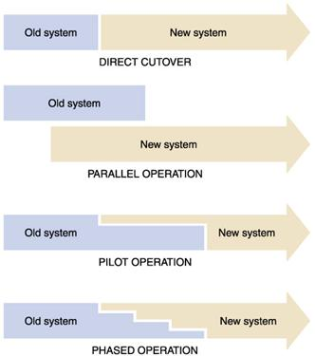

***FIGURE 9.2.1: Direct Cutover Outline***

Direct cutover strategy is a type of cutover strategy that **immediately replaces the old system with the new system** in a simultaneous order, as shown in ***FIGURE 9.2.1***. The old system would be shut down entirely so there would be no transition period where both systems are active.

While it is **less costly** for the system to be implemented, it has a **high-level risk** of the newly implemented system being entirely unusable to the client. The new system users would face many challenges to get used to the newly implemented system as well.

**Parallel Operation**



***FIGURE 9.2.2: Parallel Operation Outline***

In parallel operation strategy, the **new system is implemented while the old system is still available to use**. After a designated duration of time, the old system would be removed entirely, and the new system takes precedence as shown in ***FIGURE 9.2.2***.

Parallel operation is a strategy that could be adapted with **low risk** and **safe approach**, and thus is usually recommended to critical applications. The downside, however, being having two systems run simultaneously for a period of time and led to **high cost** of operation.

**Pilot Operation**



***FIGURE 9.2.3: Pilot Operation Outline***

Pilot operation is a system where **only part of the new system is implemented into the old system** as a means to measure its impact and effectiveness. Once the ‘pilot’ performs in satisfactory level, the replacement of the old system into the new one takes place immediately, as demonstrated in ***FIGURE 9.2.3***.

While pilot operation proves as an effective strategy in **testing new system performance** without much changes to the old system, there might be **risks of system overlap** if the system is of a large scale. Therefore, this strategy is usually applicable to moderately critical systems.

**Phased Operation**



***FIGURE 9.2.4: Phased Operation Outline***

Phased operation is a strategy where the **new system is slowly phased into the operational system**, replacing the old system in regular intervals until the new system is completely implemented as shown in ***FIGURE 9.2.4***. The part of system added in each phase could be referred as subsystems or units.

This cutover strategy is highly recommended for any critical system implementations since it has **relatively safe and conservative approach** compared to parallel and pilot operations. The new system user could be able to gradually get used to the system controls from such operation. The problem, however, lies in the **large amount of time** **required** to implement the new system this way, and the **higher cost** compared to direct cutover approach.

## 9.3 Selected Cutover Strategy

The selected cutover strategy for ISCMP is **Parallel Operation**, where the newly created centralized supply chain management software would be implemented with the old system still operative for a set amount of time until the new system is able to entirely replace the old system. The amount of time is decided by how the new system is tested or how well the new system users are trained.

Although this would be a costly operation strategy, this attempt is recommended since the supply chain management software is classified as a **‘critical application’** as the implemented system has a centralized database system that require high level of maintenance. Besides, since the core feature of the system is totally different than that of the current system (as current system relies on local database instead), it would be proven a difficulty to delegate the system in pilot operation or phased operation.

The **implementation** would carry out in the form where the newly developed system, along with its required software and hardware, are installed firsthand. While the new system is in setup, the old system, along with its local database server, are used as a **placeholder with backups** made in case of new system being corrupted or incompatible to the new system users. The users would then be **provided theory and practical training** by the system trainers until the users are familiar with the system controls.

During the period of training, the system also undergoes **regular performance and user acceptance test** to ensure its performance level and impact to the users. Once the new system reaches the point where the user could master its usage, the cutover process would be ended with approval from the project team and system clients. At that period, the old system would be removed entirely with the backup deleted from the operating system as well.

While there are no strict requirements on the system implementation, the borderline **requirements** need the user to have **matching version of the operating system** with the new system to ensure there would be no errors from version incompatibility. Secondly, a **local client-server** must be prepared along with the new system, so it could be connected to the host server that houses the centralized database for supply chain management process.

# LESSON LEARNED REPORT

Throughout the project management from this scenario, our team has learned the importance of proper management in development-based projects that especially utilized time and resource management. With the lack of sufficient time and resources in the mentioned scenario, the team has learned to organize the tasks required to complete the project based on their respective priorities, whilst identifying suitable approaches to complete the project’s planning and implementations, such as the usage of selecting applicable Project Methodology, Work Breakdown Structure, Cost Breakdowns, and so on. Besides, the team also learnt to consider multifarious aspects in delegating project activities based on not only the stakeholders’ requirements, but also the project development team’s capability and skillsets in overall. That also led to the adaption of analysis in Project Quality Management where identification of several issues required to be resolved via quality planning, assurance and control were recommended for the project plan as well.

## 10.1 Human Resource Management **[Muhammad Izzat Bin Mohd Jamil, TP035719]**

Human Resource Management (HRM) focuses on providing directions, recruitment and management of the people who work under an organization. All processes and programs that people is assigning to or is assigned to will be under the HRM surveillance. HRM department members are to provide the knowledge, necessary tools, training, administrative services, coaching, legal and management advice, and talent management oversight, which is vital for the successful operation of the rest of the organization (Heathfield, 2017).

There are four main processes that are contained in HRM, which are:

* **PLAN HUMAN RESOURCE MANAGEMENT**
  + The process of forecasting the future human resource requirements of the organization and determining the organization’s utilization of existing human resource (Juneja, 2018).
* **ACQUIRE PROJECT TEAM**
  + The process of selecting and approving human resource availability according to the list of required skills to obtain the team necessary to complete the project tasks (My Management Guide, 2018)
* **DEVELOP PROJECT TEAM**
  + The process of improving internal and external interactions between team members, developing their competencies and skills, as well as optimizing the overall team environment to increase project performance (My Management Guide, 2018)
* **MANAGE PROJECT TEAM**
  + The process in which team members’ performance are tracked, as well as using feedback, resolving strategic and operational issues, and managing changes to optimize project performance (My Management Guide, 2018).

**Issues Involved in HRM**

|  |  |  |  |  |
| --- | --- | --- | --- | --- |
| **Human Resource Management** | | | | |
| **Issue No.** | **Issues** | **Project Management Process** | **Tools & Technique** |
| 6 | There was redundancy of work performed as the Work Breakdown Structure (WBS) was done separately by each respective department and the Project Manager did not review and then consolidate those WBSs into one wholistic WBS | Initiation | **Pre-Assignment**:  Assigning teammates to work on tasks following the WBS and provide regular updates to the project manager. |
| 7 | Most of the team members have been focusing more on their daily operation support rather than tasks being assigned by the Project Manager or their respective Team Lead | Execution | **Performance Reviews**:  Conduct a daily check routine to ensure the project plan is being followed and ensure the team members are doing their task as provided. |
| 13 | There was no clear project organizational structure to manage the project. | Planning | **Organization Chart**:  With organization chart, clear organizational structure is developed start from the highest management till the individual responsibility. |

As stated in the above table, the issues that are needed to be emphasized upon are issue No.6, 7, and 13. The first stated issue, **ISSUE NO.6**, for the discussed management for Human Resource is that there was a lack of tasks being completed, as each department disregards the consolidation proposed in the Work Breakdown Structure, and as such did not refer to any other departments in performing their tasks. In order to solve this issue, the management can devise **Pre-Assignment**, in which teammates would be assigned to perform tasks while also adhering to the Work Breakdown Structure. This could be achieved by allocating staffs based on their specialties, and have them completing the tasks given in accordance to other departments as well. The project manager will also be updated on the progress of the tasks on a regular basis.

Another issue that needs to be considered is **ISSUE NO.7**, in which the team members have their focus diverted, by having them working on daily operation support instead of performing tasks given out by their higher-ups. This could very well lead towards the delay of the project as a whole, as their time management will go awry if left unsupervised. As a way to resolve the mentioned issue, the human resource management can organize **Performance Reviews**, that allows the management to perform a check routine in order to monitor the team members. Each team member will be supervised, and actions will be taken if certain members did not adhere to the assigned tasks accordingly. This method will also take the supervision of the project plan into consideration, so that each department will adhere to the provided plan.

Human resource management will also need to emphasize on **ISSUE NO.13**, which states that the project organizational structure was vague, and as such, throws the organizational structure into chaos. As such, the human resource management need to create an appropriate **Organizational Chart**. This should ensure that each team member is fully aware of their positions and tasks, and will act according to the said chart. The organizational chart need to provide a well-established structure, starting at the top of the hierarchy in terms of organizational position, all the way to each individual member with their respective responsibilities.

**PLAN HUMAN RESOURCE MANAGEMENT**

The planning of the management of human resources is crucial, as it corresponds directly to the success of the whole project management. The plan is to clearly lay out the guidelines on how the human resources should be allocated for the project management, which includes the staffing, managing, supervising, and discharging of human resources. The identification of skills required in team members for the project team is also included in the plan, as there is a need to utilise the plan in order to ascertain various training strategies for the members (Project Management Institute, 2013).

Therefore, it is essential that the project manager should take initiative in determining the set of skills required in team members for each task that has been determined for the project. Based on the skills determined, the project manager can then determine further details, which comprises of the following: The expertise required, the task to be assigned, the time period for each task, the amount of resource needed, and the estimated cost of resource. These details will ensure that the project will have enough human resources to complete the project, as well as sufficient resources can be acquired within the budget given.

For the matter of ISCMP, the details of the required expertise, the assigned tasks, and the amount of time for each task to be completed has been laid out in the Gantt chart. It is therefore vital hat the human resource management plan is carried out, as the project requires members that are proficient in their respective fields, particularly the software engineers and the UI engineers. This is because the tasks for the project will not be outsourced, save for the software tester, communication officer and procurement officer. The project will be dependent on the team members’ proficiency that has been approved by the project manager. This has also led to more reasons that the project manager should allocate resources to train the team members to polish their skills in their department.

Once the team members are briefed of their specific tasks, supervision are to be executed. The project manager is to take initiative into monitoring the members’ progress, as well as their utilization in both their work time, and the resources used to complete the tasks. The quality control department is also responsible in this regard, as they are to determine the quality of the output as the team members are working on the product. This supervision will ensure that the performance of the team members is kept under control, as well as being able to determine the ones who perform well, enabling the supervisors to endorse them with suitable rewards, thus encouraging them.

**Project Organizational Chart**

An organizational chart is a diagram that presents the hierarchical structure of an organization (RFFlow Electronics, 2016). As for this project, the hierarchical structure will be represented as a matrix chart. Instead of choosing between lining up staff along functional, geographic, or product lines, the matrix chart consists of both. Team members can report to a functional manager who can aid in tasks, as well as to a product line manager who sets the direction on product offerings.

With the utilization of the matrix chart, resources can be used more efficiently, as experts and equipment can be shared across projects. Products and projects are also formally coordinated across functional departments. As team members are in contact of many people, this aids in the sharing and flow of information, speeding up the decision process. In addition, team members are to work autonomously and do some self-management between their competing bosses, which can increase their motivation and decision making.

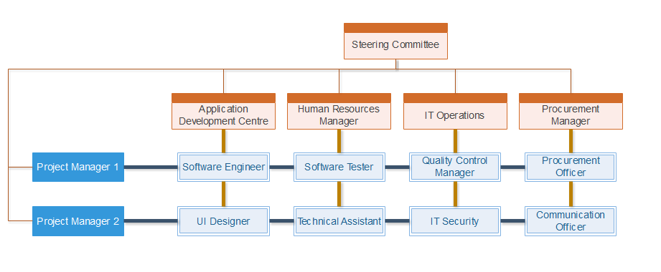

**RACI Chart**

A RACI (Responsible, accountable, consulted and informed) chart is a matrix of all the activities or decision making authorities undertaken in an organization set against all the people or roles. Therefore, this has enabled the possibility of assigning somebody responsible, accountable, consulted, or informed at each intersection of activity and role.

A RACI analysis is essential for workload analysis, as when work overloads can be quickly identified. It is also possible for a re-organization to ensure that key functions and processes does not go unnoticed. In addition to allowing duties to be distributed effectively between groups and individuals, the management can also provide a means of resolution of inter-departmental conflict.

|  |  |  |  |  |  |  |  |  |  |  |  |
| --- | --- | --- | --- | --- | --- | --- | --- | --- | --- | --- | --- |
| **Tasks/Role** | **SC** | **PM** | **PMA** | **SE** | **UD** | **HRD** | **ST** | **QCM** | **TA** | **CO** | **PO** |
| System Proposal | R |  |  |  |  |  |  |  |  |  |  |
| Feasibility Studies |  | R, A | C |  |  |  |  |  |  |  |  |
| Project Charter | C | R, A | C |  |  |  |  |  |  |  |  |
| Project Plan | I | R, A | C | C | C | C |  | C |  |  |  |
| Human Resource Plan | I | C | C | C | C | R, A |  | C |  |  |  |
| Financial Plan | I | C |  |  |  | C |  | C |  |  | C |
| Quality Plan |  | C |  |  |  |  |  | R, A |  |  |  |
| Communication Plan |  | C |  |  |  |  |  |  |  | R, A | I |
| Procurement Plan |  | C |  |  |  |  |  |  |  | C | R, A |
| Requirement Gathering | C | I |  | R | R |  |  | C |  |  | I |
| Procurement |  | I |  | C | C |  |  |  |  | R | R, A |
| Staff Management |  | I |  |  |  | R, A |  |  |  |  |  |
| Development |  | I |  | R | R |  |  |  |  |  |  |
| Testing |  | I |  |  |  |  | R, A | R |  |  |  |
| System Setup |  | C |  | R | R |  |  |  | R |  |  |
| Documentation | I | R |  | C | C | C | C | C |  |  | C |

|  |  |
| --- | --- |
| **Code** | **Role** |
| SC | Steering Committee |
| PM | Project Manager |
| PMA | Project Manager Advisor |
| SE | Software Engineer |
| UD | UI Designer |
| HRD | Human Resource Department |
| ST | Software Tester |
| QCM | Quality Control Manager |
| TA | Technical Assistant |
| CO | Communication Officer |
| PO | Procurement Officer |

|  |  |
| --- | --- |
| **Code** | **Meaning** |
| R | Responsible (one who performs the task) |
| A | Accountable (one who is accountable to the task) |
| C | Consulted (one that needs to feedback and contribute to the task) |
| I | Informed (one that needs to know of the decision/action) |

**Resource Histogram**

Resource histogram is a visual representation that is usually used by the project management team, in order to provide the details of the amount of time used for a specific resource to be worked on over a predetermined time period (Project Management Institute, 2004). Resource histogram proves to be useful as it can allow the project management team to easily view the available resources, which resources are being used at the moment, as well as the amount of time taken for the resource to be in task.

**Motivational Theory**

In order to keep team members motivated and productive throughout the project, it is important for the project manager to be acquainted with motivation theories that will aid in the efficiency of the team members, thus increasing the quality of the project output. These motivation theories can also inspire team members to take action and become self-directed (Papa, 2017). Below are the several models of motivational theories.

**Maslow’s Hierarchy of Needs**

The hierarchy of needs theory was developed by Abraham Maslow in 1943, in his paper “A Theory of Human Motivation” (Mark, 2014). This model identifies one’s needs on a progressive pyramid, starting from the most basic needs to the least basic needs. The theory implies that when motivating, only unsatisfied needs can be fulfilled, rather than fulfilling already satisfied needs. It is also noted that team members can be motivated by having the management meeting their most basic human needs and building on them (Papa, 2017). The diagram below represents the five needs that Maslow has identified.

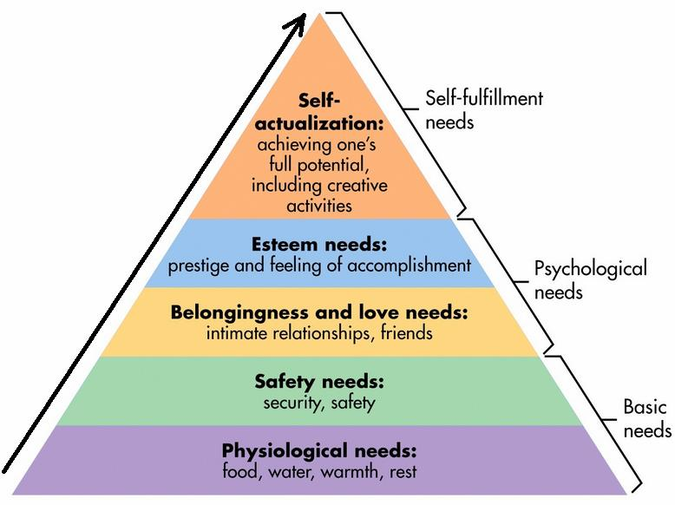

**Herzberg’s Two Factor Theory**

Coined by psychologist Frederick Herzberg in the 1950’s (Mark, 2014), this factor theory identifies two main sources of motivation for the people involved in the workforce. The first being **hygiene factors,** which involves in the working environment, the salary, the job security, as well as the style of management. These lack in these factors can lead to the employees’ dissatisfaction, leading to the lowering of motivation in work. The second factor is **motivator factors,** which is basically satisfying the employees to motivate them. These motivations relate to their achievements, status, recognition, responsibility, and potential growth. Simply put, with the increasing in this kind of factors, the employees will be more motivated in their tasks (Papa, 2017).

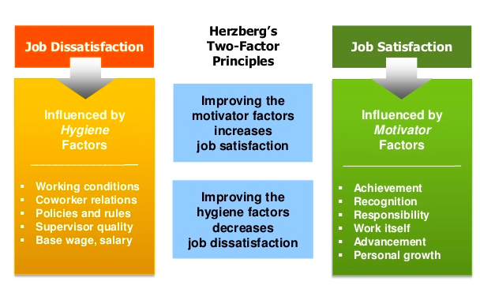

**ACQUIRE PROJECT TEAM**

This process involves in the obtaining specific people that is essential for the completion of all the phases of the project. The finalized team members would fulfil all of the specific requirements with their qualifications and abilities that they can contribute to the project. Usually, the project team is made by having the project management team filtering and selecting from the available candidates (Project Management Institute, 2004).

Acquiring project team is not without criteria to adhere to. It is vital that the project management team refer to these criteria as guidelines when selecting team members for the project.

**Level of experience** – The project management team needs to analyse information regarding the current level of experience of team members for the project, and compare it to their required level of experience.

**Level of interest** – The project management team is to assess the team members’ enthusiasm in participating in the project.

**Personal qualifications** – The project management team needs to evaluate each team member’s skills and talents for them to qualify into the involvement of the project, as well as their compatibility with other team members.

**Availability** – The project management team collaborates with the functional managers, and identifies the potential team members’ availability for the project.

**Knowledge** – The project management team assesses the team members in terms of their competency and proficiency (My Management Guide, 2018).

**Negotiation**

This method can allow the project management team to assign staffs between multiple project sections, so that each section of the project will have proper amount of human resources in its disposal within the given time frame (My Management Guide, 2018). In this case, the project management team will need to make negotiations with the other project managers in order to be provided with additional team members. The management should also be able to make an approach to others, as the means to execute this plays a large role in the negotiation with staffs in regards to the assigning of their tasks.

The project management team can negotiate with the functional managers regarding the staffs’ work time, as well as their salary for the duration of the project. In addition to this, the management team can also request for extra staff from GL (if needed), without having to make more expenses on the budget.

**Acquisition**

While most requirement for the projects are fulfilled by team members, there will be certain roles that need to be carried out from external sources, as the available resources are not suitable for the specific roles (Learn Certification, 2015). In this case, there is a need in external opinion on the developed application for the project – which is why there is a need in software testers in order to test-run the software prototype.

**DEVELOP PROJECT TEAM**

This process involves in the improvement of competencies, interaction between team members, and overall team environment in order to boost the performance of team members during the execution of the project (Project Management Institute, 2013). The development of the team members will result in the improvement in terms of teamwork, skills, motivation, and project performance as a whole.

**Tuckman Model**

First coined by psychologist Bruce Tuckman in his 1965 article “Developmental Sequence in Small Groups”, he came up with the phrase “**forming, storming, norming** and **performing**”. This phrase is to describe the steps that most teams adhere to in achieving excellent performance in their project. It was only later that Tuckman added another stage in the sequence, namely “**adjourning**” (MindTools, 2016).

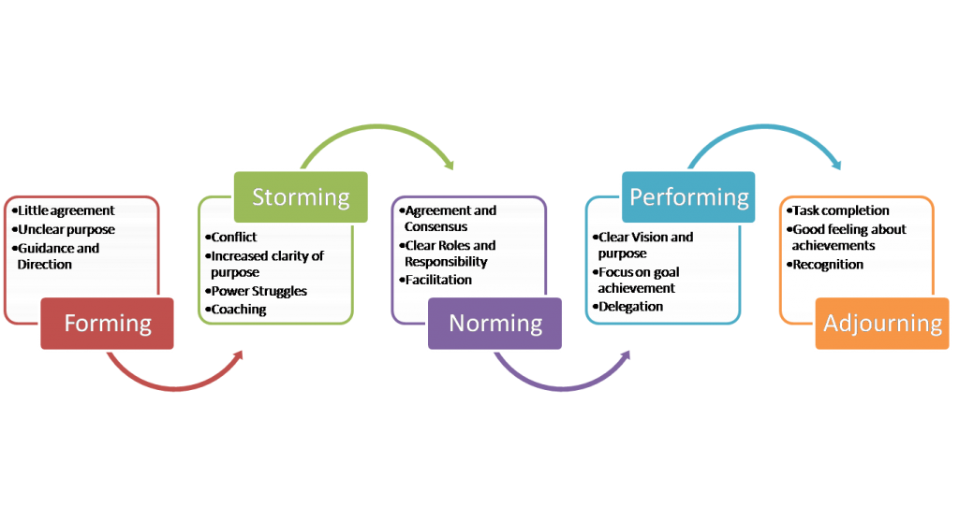

**Forming**

This starting stage usually presents team members as being positive and polite, as they try to create a good first impression towards others. While some may appear anxious since they are not familiar with the project, most should appear to have some enthusiasm in the upcoming tasks for them (MindTools, 2016). As different people have different sociability, it may take some time for the team members to get used to each other, as well as putting effort in establishing a personal identity within the group (Mullins, 2010).

On this stage, the project manager should take charge in directing the team, as well as establishing clear objectives for both the overall team and individual team members.

**Storming**

The next stage is the storming phase, in which members will be presented with conflict among each other. The conflict can be stemmed from multiple reasons, one of it being that the working styles of members differ from each other. Not being used to others’ work style means that members usually cannot synchronize with them, and as a result, may cause unexpected problems in the future. Other reasons include members challenging higher authorities, competing for positions, feeling overwhelmed by workload, or feeling uncomfortable with project manager’s approach. At this point of the stage, team members may experience a degree of stress, as they have not strongly bonded with the other members, and not have the support of established process (MindTools, 2016).

By this point, the project manager should take initiative in establishing processes and structures for the team members. The project manager should also supervise the team members as they build trust and good connections with each other, as well as resolving any conflicts that might occur. Another activity that the project manager can take part in is to use psychometric indicators, for example, the Myers-Briggs Type Indicator (MBTI) to assess and aid the team members of their work styles, strengths, and weaknesses (MindTools, 2016).

**Norming**

During this stage, team members should be accustomed to each other, in which they start to resolve their differences, acknowledge others’ strengths and weaknesses, and respect the higher authorities. As such, team members should be able to mix and socialize together, as well as help each other where needed. Thus, members will be committing towards the goal as a team, and will be able to advance in a progressive manner.

During this stage, it is best that the project manager should step back and aid team members in taking in responsibility for their progress on their tasks for the project (MindTools, 2016).

**Performing**

The performing stage should present with the team members performing their tasks well, without any resistance, towards the completion of the overall project. The project manager can entrust tasks to the team members without worry, and can focus on the development of the team members. As the team’s structure is stable, members who join nor leave will neither affect the performance of the team as a whole.

As stated, the project manager can assign tasks and projects as far as possible. The project manager can now be able to divert their attention towards other goals and areas of work that needs attention (MindTools, 2016).

**Adjourning**

This final stage will be reached by team members ultimately. It is at this stage that a team finally wraps up their work and then dissolves, once the team has fulfilled their goals and objectives. It is important that the team is dissolved on appositive note. Members may exhibit a sort of mourning, as they feel a sense of loss when the group comes to an end. In addition, members may also display some uncertainty or insecurity about their future after the project ends (Swarthout, 2015).

Thus, it is essential for team members to be recognized for their achievements and celebrate the team’s overall success. By viewing past experiences positively, members who might work with each other again will have an easier time synchronizing back together again (MindTools, 2016).

**Myers-Briggs Type Indicator**

Personality tests can help in the identification of the potential skills of team members, therefore allowing managers to advantageously and strategically position members that match their potentials. The Myers-Briggs Type Indicator (MBTI) personality types reviews the research on understanding the personality traits possessed by competent members. It defines the 16 MBTI types, and which of them were most likely to perform the tasks and responsibilities assigned in accordance to the position with proficiency. Furthermore, it clarifies on the functions of the MBTI system, as well as listing the MBTI types that suitable enthusiasm in respective to different positions (Gehring, 2007).

**Team Building**

Team building involves in the process of taking a collection of individuals with different needs, backgrounds, skills and knowledge, and transforming them by various means into a unified and effective work unit. The transformation process merges the goals and energies of individual members, supporting the objectives of the team as a whole (David L. Wilemon, 1983).

A simple yet effective team building activity would be to host a pizza party. Generally, as food brings people together, this activity can provide members an avenue where they can start talking and sharing. At this point, they will begin to see each other in their roles from a different perspective. Another advantage of this activity is that it is simple enough to be planned and held on a more regular and consistent basis. This will further encourage team members to connect with each other, gaining each other’s trust and solidifying their relationship.

**Reward and Recognition**

The reward and recognitionsystem’s main purpose is to ensure that team members feel appreciated and that their work has not gone unnoticed. Besides that, it also serves as an excellent way of pushing team members to do better and better over the course of the project life cycle. As such, each member should be aware of the reward and recognition system so that they can continuously try to achieve for the same rewards. Hence, team members will have a reason to improve themselves in their work, further motivating them towards the project goal (Dwevedi, 2017).

As part of team-building, individual members can express on how they would prefer to be recognized and rewarded. Since members will likely differ in what motivates them, the team can decide on how to show recognition in any outstanding work by any member and how to celebrate achieving milestones. The project manager should also inquire members on how they would like to be rewarded. Recognition is appreciated most when it is timely, specific, and personal, and such, the project manager should be alert for opportunities and not hesitate in offering a simple note or word of appreciation (Bullwinkle, 2016).

**MANAGE PROJECT TEAM**

To manage project team is to track team members’ performance, provide feedback, resolve issues, and manage team changes to optimize project performance. This process impacts team behaviour, manages conflicts, resolves issues, and appraises team members’ performance (Project Management Institute, 2013).

**Observation and Conversation**

Observation and conversation is one of the interpersonal and team skills that offers a direct way of assessing individuals in their environment and the way they perform their tasks and carry out processes (Project Management Institute, 2017). The project manager can then use this to know more about the team members, thus getting closer to the team members. With this technique, the project manager can engage with the team in order to determine and resolve any problems in particular morale.

**Project Performance Appraisals**

This technique involves in the team members getting feedback from the project supervisors. Besides that, it also includes clarification regarding roles and responsibilities, constructive feedback to the team members, discussion on the unresolved or unknown issues and establishment of the future goals and expectations (Neham, 2014). The technique enables the team members to reflect on their constructive criticism from their supervisors in order to improve on their overall performance. As for the project managers, they will be able to reward members with superior performance, and discipline the ones with minimal performance.

**Interpersonal Skills**

Interpersonal skills reflect on the project manager’s ability to use technical, personal and conceptual skills to capitalize on the strength of the team members.

Project managers should have the following interpersonal skills:

* Leadership
  + A leader is particularly important at the start of the project, as they need to define the vision of the project and relay this vision to the team, keeping every team member on board with the project goals (Fichtner, 2016).
* Team building
  + As a project manager, the team members should be able to look up to the manager, as they will play a vital role in case of a conflict. As such, the project manager will have to create trust within the team members before the manager can start on creating a sense of teamwork (Pradip, 2017).
* Motivation
  + With a good motivation skill, it will grant the project manager the ability to create an environment that allows team members to meet the objectives of the project, all the while being satisfied with their accomplishments (Fichtner, 2016).
* Communication
  + Communication is one of the most essential aspect in managing a project, as it improves relationships among all team members, establishes trust, and keeps everyone motivated and on schedule (Fichtner, 2016).
* Decision making
  + The project Manager can make a decision based on schedule constraint, quality, and acceptance criteria. Therefore, the success of the project relies greatly upon the decision making skills of the project manager (Pradip, 2017).
* Negotiation
  + This skill helps the project manager by reaching an agreement or compromise on issues that causes a problem or delay. A good negotiator can manage situations so that all parties involved feel that their opinion was taken into consideration (Fichtner, 2016).

**Conclusion**

Human Resource Management has proven to be an important factor in organizing a project. It is said that people are the most important asset, and as such, this management proves to be vital by making use of human resource with utmost efficiency. In order for the ISCMP to be completed with success, the process of human resource management is to be taken with heavy consideration. The planning of human resource management, the acquiring of the project team, the developing of the project team, and the managing of the project team has given quite an insight on the inner workings of this management. With the detailed analysis and execution of each phase in order, it has led to the development of a suitable team for the project.

The managers also benefitted from this, as they are able to salvage some moral values from the leading of the team members, as well as being able to brush up their own leadership skills. All in all, the techniques, skills, values, etc., learnt here can be taken as an example, encompassing all departments alike.

## 10.2 Procurement Management **[Balram A/L Krishna Kumar, TP035446]**

Project procurement management manages the resources for the project such as products, services or parts of the project’s deliverables handled by third party suppliers. The project resource management process includes procurement planning, conduct procurements, control procurements and procurement closing. In Information Technology Project, procurement includes the process of managing IT assets and outsource part of the project deliverables to third party software vendors.

Below are the overview phases of project procurement management based on Project Management Body of Knowledge:

|  |  |
| --- | --- |
| **Phase** | **Description** |
| Planning procurement management | Process of documenting project procurement decisions, specifying the approach and identifying potential software vendors and hardware suppliers. |
| Conduct procurement | Process of obtaining responses from software vendors, selecting software vendors and awarding a contract. |
| Control procurement | Process of managing procurement relationships, monitoring contracted software vendors’ and hardware suppliers’ performance and making changes and corrections if applicable. |
| Closing procurement | Process of completing project procurements and termination of contracts. |

***Table 1.1 Project Procurement Management Phases***

* Plan Procurement Management

Procurement Management planning is the first phase of project procurement management, it is a process of defining procurement requirements for the project from procurement development till the contract termination process and documentation on the project procurement decisions, specifying the approaches and identifying the software vendors and hardware suppliers. The decision of the hardware purchases and software modules to be outsourced will go through “Make-or-Buy analysis”, “Expert Judgement”, “Market Research”, and “Meetings” techniques.

* + Procurement Management Planning

Procurement management plan defines the procurement requirement for the project with managing the contracts awarded to the venders. The main contents of the procurement management plan include the type of contract usable for the contracted vendors, vendor’s selection criteria and contract approval processes. The full content with small description on the contents of procurement management plan document are as below:

|  |  |
| --- | --- |
| **Content Title** | **Description** |
| Procurement management approach | Defines the necessary steps and responsibilities for the entire procurement process |
| Procurement definition | Describe the items including but not limited to hardware and software to be procure. |
| Types of contract to be used | Describe the type of contracts to be awarded to successful bidders |
| Procurement risks | Identify and list out the potential risk in procurement management |
| Procurement risks management | Defines the methods and plans to manage the risks. |
| Cost determination | Defines the cost determination techniques to be used in buyers’ selection criteria |
| Standardized procurement documentation | Describe the standard of the procurement documentation. May include document templates. |
| Procurement constraints | Describe the constraints within the procurement management. May be related to schedule, cost, scope and more. |
| Contract approval process | Defines the process of contract approval based on the decision criteria. |
| Decision criteria | Defines the criteria required for selecting successful bidders. |
| Vendor management | Describes the roles and action of procurement team to ensure the contracted vendors provide the deliverables agreed |
| Procurement activities performance matrix | Records the performance of the vendors on delivering the deliverables with scale. The scales may vary among companies. |
| Sponsor acceptance | Signature of project sponsors to indicate the approval of the procurement management plan |

* + Statement of Work

Procurement statement of work describes the task to be accomplished and the deliverables by the contractor, included in the procurement management plan templates. SOW content includes the scope, deliverables, responsibilities, contract timeline which includes the fee schedule and deliverables completion criteria. The content with its summarized description can be found as below:

|  |  |
| --- | --- |
| **Content Title** | **Description** |
| Period of performance | Defines the start date and end date of the contract |
| Engagement resources | Describe the resources needed during the work process |
| Scope of work | Defines the detail and concise scope of deliverables which the vendor required to deliver |
| Contractor responsibilities | Defines the responsibility of the contractor or vendor agreed upon the contract |
| Client responsibilities | Defines the responsibility of the client or buyer agreed upon the contract |
| Fee schedule | Defines the payment regulations with defined payment schedule. |
| Our-of-pocket expenses | Defines the regulation on the payments made by the client on out-of-pocket expenses (may include meals and local transportation fees) |
| Completion criteria | Defines the criteria of completion and ending of the contract. |
| Assumptions | Defines the assumption which are specific for the contracted project / deliverables |
| Project change control procedure | Defines the procedure required to follow when project specification changes take place |

* + Other Procurement Documentations
    - Request for Information (RFI)

Request for Information, in short RFI. Document is used to gather information from the vendors in formal and structured way. The document is used when there are multiple possible vendors and not enough information about the vendor’s profile. RFI document will be used to prepare the RFQ and PFP document.

* + - Request for Quotation (RFQ)

Request for Quotation document is used to obtain detail information on the vender’s proposal on delivering the buyer’s requirement with the proposed cost. The information collected form RFQ will be used to determine the vendors to be contracted with.

* + - Request for Proposal (RFP)

Request for Proposal (RFP) document is used to invite the vendors to submit their proposal on the buyer’s desired goods or service. The main goal of this document is to identify the suitable vendors to meet the buyer’s needs.

* Items to be Procured

For the project, the following hardware and software need to be included in the plan procurement management process:

* + Hardware

Hardware is required to develop the software as well as executing the deliverables during the production phase. The hardware required for the project are as below:

|  |  |
| --- | --- |
| **Hardware** | **Description** |
| Computer devices | Required for the development of the software, plus software debugging and monitoring. |
| Servers | Act as the data processing center for deliverables as well as incoming web requests. |
| Server racks | Act as the container for servers. |
| Network switch | Use to establish connection to multiple electronic devices |
| Modem | Provide network connection between server and public network. |
| Router | Provide local network routing service. |
| LAN cables | Wired connection between electronic devices. |
| Uninterruptable power supply | Provides emergency power supply for servers to shut down in case of power supply breakdown. |

As the project team, have previously purchased new hardware frequently and the delivery process of these hardware that has been purchased and develop a plan to purchase the remaining required hardware in market research process.

Due to the overfunded budget on hardware and software, the procurement team will require comparing the require comparing the required hardware prioritizing the hardware fees from different vendors in market research process. Meetings with the hardware vendors can be conducted to bid for a lower price of the hardware. Expert judgement will be done after all the hardware vendors made their proposals to identify the hardware vendors to be purchased from.

* + Software

As the project has a short leftover timeline left to deliver the deliverables and the progress of this project is slow, part of the deliverables is required to be outsourced to 3rd party software vendors to deliver the software in time.

In make-or-buy analysis, the procurement team decided on the software modules to be outsourced based on development team abilities and time required to deliver the software modules and current project budget. If the project team is unable to deliver a software module. As the purchasing of IT assets has led the project budget to be overfunded, the procurement team will be required to consider contracting the best software vendors with lower cost in market research technique. The selected software module that will be outsourced to third party vendors are:

1. Transportation Management Module
2. Yard Management Module
3. Manufacturing Management Module
4. Inventory Management Module
5. Product Management Module
6. Customer Requirement Module

In market research, the procurement team will look for third party software vendors as bidders to outsource the selected software modules. The procurement team needed to make sure that the selected bidders has the capability to deliver the outsourced modules during market research. Meetings with the bidder can be conducted to gather more information on the bidder’s capabilities. The outsourcing software modules are divided equally into 2 groups, which requires the software vendors to choose one of the groups to be contracted. The grouping of the software modules is as follows:

|  |  |
| --- | --- |
| *Group A* | *Group B* |
| Transportation management module | Yard management module |
| Manufacturing management module | Inventory management module |
| Product management module | Customer requirements module |

* Contract types

A contract is a legally binding agreement between two or more parties. The contract categories available for procurement management are Fixed-Price Contract, Cost Reimbursable Contract and Time & Materials. The description on the procurement contract types are described in the table below:

|  |  |
| --- | --- |
| **Contract category** | **Description** |
| Fixed-Price contract | The agreement on the tasks, cost and time are fixed after the contract has been signed |
| Cost Reimbursable Contract | The seller is reimbursed for meeting or exceeding the selected project deliverables and objectives. |
| Time and Materials | Mixture of both Fixed-Price Contract and Cost Reimbursable Contract. |

In this project, the contract type that will be used to award the successful bidders is Firm Fixed-Price Contract in Fixed-Price Contract category due to the constraint in project timeline and the constraint in project budget.

* Procurement team roles and responsibilities

|  |  |  |
| --- | --- | --- |
| **Role** | | **Responsibility** |
| Project Manager | | Overall coordination of procurement programs |
| Procurement Manager | | Collaborate with project manager to make decision on procurement items specification. |
| Procurement Team | Procuring Officer | Directly communicate and negotiate with vendors and prepares a list of potential vendors |
| Legal advisor | Provide advice on contracts and assist in negotiation with vendors |
| Business Analyst | | Drafting the specification of the items to be procured |

* Conduct procurement

Conduct procurement is the process of obtaining the venders’ response, selecting venders and awarding contract to the vendors (Project Management Institute, 2013). In this process, the procurement team will require obtaining software vendors’ response by advertising the contracts to the bidders found during market research on the capable software vendors. Below is the schedule for conduct procurement process:

|  |  |  |  |
| --- | --- | --- | --- |
| **Task name** | **Start date** | **End date** | **Duration** |
| Advertise Job | Fri 17/3/17 | Wed 22/3/17 | 5 days |
| Conduct Bidder Conference | Thu 23/3/17 | Thu 23/3/17 | 1 day |
| Job Proposal Review | Fri 24/3/17 | Fri 24/3/17 | 0.5 days |
| Award Contract to Vendors | Fri 24/3/17 | Fri 24/3/17 | 0.5 days |

To ensure that all selected software vendors have clear understanding on the software module requirements, the procurement team can conduct bidder conference. Before the bidder conference begin, the procurement team should develop evaluation criteria for the selection of the software vendors. The developed evaluation criteria should not be revealed to the bidders. The evaluation criteria for choosing the software vendors are:

* Proposed cost within project budget
* Proposed development time within project timeline
* Experience on delivering similar software module

During bidder conference session, the procurement team should hear questions raised by the bidders and answer those questions. Before ending the bidder conference session, the procurement team will announce the deadline of the proposals from the software vendors. At the end of the bidder conference, the software vendors will begin developing their proposal.

After collecting proposals from the bidders, the bids will be evaluated by the procurement team based on the evaluation criteria built. The procurement team can use scoring technique in tender evaluation matrix to determine the vendors to be contracted. The vendors to be contracted will be determined based on the total score of the criteria listed in the matrix. A sample of the evaluation matrix is attached in appendix B.

As the plan for outsourcing the software modules are outsourcing 3 software modules as a package to one software vendor, bidders with the highest total score on a software module package will be awarded with a contract. Once the 2 winning bidders are chosen, the bidders will be awarded with a contract. Before awarding contract to the successful bidders, the procurement team will require conducting meetings with the successful bidders for procurement negotiation. The purpose of procurement negotiation is to clarify the requirements and other terms related with the contract on the outsourced software module so that agreement can be reached for both parties on the contract. Members from different team within project may join the procurement negotiation to aid and clarification on the software module requirements.

Once both software vendors and the team are on the agreement of the final contract content, the procurement team will require preparing an agreement document to the successful bidders. An agreement can be called as a contract, subcontract or a purchase order. The agreement document content may be varying based on the type of contract used.

* Control procurement

Control procurement is the process of managing procurement relationships, monitoring contract performance and making changes to the contracts. In this process, the procurement team will require monitoring contracted software vendors’ performance and modification of the original contracts with requirements change requests.

* Change request

When the outsourced software module requirement changes, the procurement team will require obtaining the approval document of the change request. This document can affect the original content of the contract awarded to software vendors. The content of this document may include changes in statement of work, pricing or descriptions of the deliverables.

For each requirement changes on the outsourced software module, the contracted software vendor and procurement team will require conducting contract change control system. Change control system which includes the change request document allows the change request to be analyzed, approved, declined and managed. A new contract will be given to the software vendors after the agreement on the change request.

* Performance monitoring

Monitoring software vendors’ performance is part of the control procurement process, which monitor the progress and quality of the software vendors as compared with the awarded contract. The purpose of monitoring software vendors’ performance is to identify the performance success or failure as a part of risk management. The performance of software vendors can be recorded through performance reporting and inspections process.

In performance reporting, the performance data of the software vendors will be evaluated against the agreement requirement. The progress of the software vendors can be tracked by sending daily progress report from the software vendors. The format of the report can be varying depends on the reporting format of the software vendors.

Inspection and audit are required by the contractor to monitor the performance of the contracted vendors. This process can be conducted during the execution phase of the project. Representatives from the respective software vendor’s procurement team may join the inspection and audit if the agreement is made in the contract.

* Payment system

Payments by the contractor to the software vendors are done by the contractor’s accounts payable system. In GSCMP, the outsourced software modules are breaking down into software components. The payments will be received by the software vendors for each of the software components completed. The payment figure may be altered based on the comparison of the deliverables with the expected output from the software vendors in close procurement process. The maximum payable amount for the software components in the outsourced modules is listed below:

|  |  |  |
| --- | --- | --- |
| **Software module** | **Software component** | **Payable amount** |
| Transportation Management Module | Transportation Execution | $3,000.00 |
| Transportation Follow-up | $3,000.00 |
| Transportation Measurement | $4,000.00 |
| Yard Management Module | Yard Shipment Process | $1,000.00 |
| Gate Control | $3,000.00 |
| Dock Management | $3,000.00 |
| Seal Management | $3,000.00 |
| Manufacturing Management Module | Production Process Control | $3,500.00 |
| Workflow Simulation | $1,000.00 |
| Resource Planning | $1,000.00 |
| Assembly Line Optimization | $3,500.00 |
| Factory Layout Planning | $1,000.00 |
| Inventory Management Module | Stock Tracking | $3,000.00 |
| Loading & Unloading | $1,500.00 |
| Inventory Mix Optimization | $4,000.00 |
| Optimal Inventory Report | $1,500.00 |
| Product Management Module | Product Catalogue Management | $4,000.00 |
| Product Information Management | $3,000.00 |
| Packaging | $3,000.00 |
| Customer Requirements Module | Checking Stock Availability | $4,000.00 |
| Processing Requirements | $2,000.00 |
| Feedback Collection | $4,000.00 |

* Claims administration

Claims administration takes place when the sellers, which are vendors is unable to reach an agreement on the contested changes, also variously called as claims. Claims administration also manages the changes of the contracts between buyer and sellers. If any of the software vendors is unable to reach an agreement on the requirement changes, the claims are required to be resolved by both parties through negotiations. If both procurement team and software vendors are not willingly to resolve the claim, the claim can be resolved through the court system.

* Records management system

Records management system is used by project manager to manage project documents including contracts and procurement document. All documents created in procurement processes must be recorded to maintain the audit trail including procurement plan and contracts.

* Close procurement

Close procurement is the process of completing each procurement. In this process, the procurement team will document the agreements and other related documents for future reference and terminates the contracts with software vendors. The information gathered in close procurement process can be used as the basis for contractor evaluations. The sub processes that requires the procurement team to conduct are:

* Procurement audit

Procurement audit is the process of reviewing the procurement process from plan procurement process to control procurement process. The information gathered during the procurement review such as the performance of the software vendors can be used by GSCMP procurement team to make decision in future procurement process.

* Procurement negotiations

The main purpose of procurement negotiations is to resolve the outstanding issues, claims and disputes. If the contracted software vendors deliver their deliverables with defects such as bugs in the software module, the procurement team will negotiate with the software vendors to resolve the issues. An example of the solution will be reducing the payment to the software vendors.

* Contract closure

After the procurement audit and negotiations, the procurement team will close the procurement by closing the contract with the software vendors and provide a formal contract termination notice. The contract closing process may fall into one of the categories:

• **Fulfilment by performance**

The seller has completed their work successfully

• **Mutual Agreement**

Bad relationships between buyer and seller

• **Frustration**

The procurement process face situations beyond control

• **Operation of law**

Procurement process face situations that requires action to be taken by court

* Lesson learned documentation

Before the ending of procurement closing process, the procurement team will require preparing lesson learned documentation to record their experience with the software vendors and may include procurement improvement recommendations. The records will be used to improve future procurement processes.

## 10.3 Communication Management **[Ang Chee Siah, TP038259]**

**INTRODUCTION**

In an undergoing project, communications management is a vital element to ensure that information is effectively delivered to and received from every departments of the project team. This element of project management includes roles in managing effective meetings between teams, forming an efficient communication means for all departments, applying appropriate technology usages for ease of interaction, and providing enough templates for formal communication methods. In general, there are 3 processes involved in a project’s communications management: **planning**, **managing**, and **controlling**.

**ISSUES INVOLVED**

|  |  |  |  |
| --- | --- | --- | --- |
| **Communication Management** | | | |
| **Issue No.** | **Issues** | **Project Management Process** | **Tools & Technique** |
| 1 | The steering committee (which consist of the board of directors, CEO and Senior Managers of the organization) do not recall of being presented the project feasibility study by the Project Sponsor or the Project Manager to them. | Initiation | **Communication Requirements Analysis**:  Determine all stakeholders’ means of communications, calling intervals and recommended timing plus the duration |
| 6 | There was redundancy of work performed as the Work Breakdown Structure (WBS) was done separately by each respective department and the Project Manager did not review and then consolidate those WBSs into one wholistic WBS | Initiation; Planning | **Meetings**:  Gathers the stakeholders for a face-to-face deliverance on the working requirements for a complete, centralized WBS  **Issue Logs**:  Identify all issues that the project has and delegate manpower easier based on the problem-solving strategies’ comparison |
| 7 | Most of the team members have been focusing more on their daily operation support rather than tasks being assigned by the Project Manager or their respective Team Lead | Execution | **Performance Reporting**:  Conduct a daily-to-monthly check routine to ensure the project plan is being followed and ensure the team members are doing their task as provided. |

**PLAN COMMUNICATIONS MANAGEMENT**

In this stage, all **stakeholder’s needs** on information and communications are **identified**. An appropriate **communication approach** would be decided based on those communication needs and requirements.

While it is necessary to have a project management plan, registers of stakeholders, enterprise environmental factors and organizational process assets to start on a plan communications management, this process could create a **communications management plan**, along with an **updated project document**.

**Communication Requirements Analysis**

Firstly, the stakeholders’ needs in the project’s communication channels must be understood via **data collection and analysis**. Each stakeholder would be inquired of the **preferred communication** **means** individually or collectively, which would then form a suitable planning template for all stakeholders, normally by plurality.

However, the analysis could form either a generic template or event-specific templates according to the level and frequency for the stakeholders needed to communicate among the project team (España, et al., 2009). In this case, a generic template would be produced as the project team has less need of frequent contact with outside parties relative to a typical project that requires event-specific templates. It also meets the needs of the waterfall model management method to have a central communication system that creates less confusion and more focus.

To solve **ISSUE NO. 1** via this method, a meeting – by gathering or personal visit – among the steering committee is required to **obtain information on all their frequent means of communication** by creating a plan (reference to plan template at ***TABLE 10.3.1***)and devise the best means of information deliverance that **can reach everyone in shortest time possible**. Although straightforward and simple, this solution is necessary to **prevent “hit-and-miss” scenarios (situations where the person in question cannot be contacted)** in informing the important project members, Board of Directors included, by determining a universal communication means. In case of “hit-and-miss” via the universal channel, the alternative contact details via the collection and analysis could be used immediately to prevent further delay.

**Communication Roles and Responsibilities**

While all stakeholders’ requirements on communication needs are needed to be identified, the communication plan should be made based on their **priority** on their **roles and** **responsibilities** as well. Based on the priority level, the planning template for communications could be more organized to **prevent disturbances** such as ‘role blurring’, a risk that involved staffs within a project team consistently unsure about their responsibilities (Esther, et al., 2009).

**Communication Management Plan Template**

A plan template is vital to create a communications plan in order to **understand all available options** of interaction within the project team, in the **quickest and clearest manner** possible. In this case, a template in a form of **generic table** is proposed, including sample inputs as reference in ***TABLE 10.3.1***:

|  |  |  |  |  |
| --- | --- | --- | --- | --- |
| **STAKEHOLDER NAME** | **ROLE(S)** | **DOCUMENT**  **(NAME & FORMAT)** | **AVAILABLE IN (PLATFORM)** | **CONTACT BY (DEADLINE)** |
| Monos Krome | Quality Control | Progress Report  (Printed Copy) | Face-to-Face;  WeChat | Each week, Thursday |
| Lunaire Mun | UI (User Interface) Designer | User Interface Design Draft (.ai Format & Printed Copy) | E-mail;  Face-to-Face | 24/7/2018 |
| Apolloa Sun | Software Engineer | Status Report  (E-mail) | Discord;  E-mail; LINE | Each week,  Monday |

***TABLE 10.3.1: Communication Management Plan Template for ISCMP***

**Communication Technology**

In terms of communication technology in a project, it could be generally divided into 2 main channels: one that requires document transfer, and one that is meant for personal chats and talks only, as proposed by the sample data collection on Morey’s article (Morey, et al., 2013).

While in terms of communication, **document-transfer-based** channels are mostly used by the staffs on the development-based team such as Software Engineers and UI Designers in this scenario. Services such as *SourceTree* and *GitHub* proves a suitable medium for inter-changing software progress and codes to ease the process of creating certain features in the same program.

Channels that are more **chat-based** from *WhatsApp* and *Skype* would prove a more decent approach for in-depth discussions on concepts, proposals and feedbacks among the management teams, where Project Managers would frequently use to contact development teams and board of directors to update on the project’s progress and deliver opinions.

**Communication Models**

Communication model is a representation on how communication, in general, works using senders and receivers as the each ends of the model, with the communication channel itself acting as the medium connecting them together along with several elements as well, such as the reference diagram in ***FIGURE 10.3.1***.

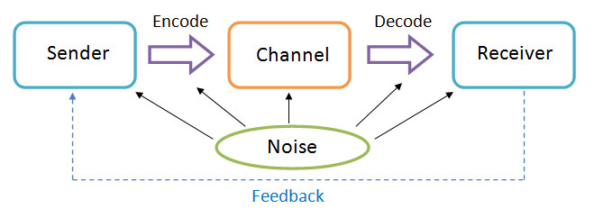

***FIGURE 10.3.1: Basic Communication Model based on Shannon-Weaver Model***

Communication model is a concept that would be applicable when devising a universal communication channel to everyone in the project, as it allows the **anticipation on how the message is transferred** (McQuail & Windahl, 2015) via the following elements:

1. **Sender**: How many people would be sending the information via this channel?
2. **Receiver**: How many people would receive the information, and in which format?
3. **Encode**: Would the message encodes into the information the way sender wants?
4. **Decode**: Would the information decodes into message the way the receiver wants?
5. **Noise**: What interference would occur when using the channel, and how big is the impact?

Using a comparison between 2 communication means, *Face-to-Face* and ­*E-mail* for a scenario where the UI Designer would submit a design draft to the Project Manager in a 1-time basis*­*, a comparison could be made between these two methods in ***TABLE 10.3.2***:

|  |  |  |
| --- | --- | --- |
| **Face-to-Face** | **Communication Elements** | **E-mail** |
| UI Designer (in person) +  Design Draft Documents | Sender | UI Designer’s E-mail Account |
| Project Manager (in person) | Receiver | Project Manager’s E-mail Account |
| Verbal input from UI Designer + Display of Design Draft Documents | Encode | Word input from UI Designer +  Digital Copy of Design Draft Documents available for view |
| Project Manager listens in real time  (verbally sends feedback when needed) | Decode | Project Manager views E-mail when he is free  (reply via E-mail when needed) |
| * Venue acceptable by both sides * Surrounding sound (if the venue is too loud) | Noise | * Different interpretation of words and terms in E-mails * Requirement of internet service |

***TABLE 10.3.2: Face-to-Face and E-mail Comparison using Shannon-Weaver Model***

Based on the comparison, Face-to-Face method relies more in **verbal exchange** between senders and receivers while E-mail method relies more on the exchange of information via E-mail accounts that mainly uses **written words** in displays. In contrast, the usage of Face-to-Face method requires interaction **on-the-spot** for both sender’s and receiver’s sides while E-mail method **requires devices** **that contains their respective E-mail accounts** regardless of the location.

While the respective encode and decode methods are unique at their own way, the noise factor determines that Face-to-Face would be a better option for as this method **only has downside in terms of venue of selection**; while E-mail methods require use of internet service and **information deliverance might not be as effective**, especially the meeting is for 1-time only.

Therefore, it is recommended for the use of **Face-to-Face method** for the meetings, while E-mail method could be used as an alternative for more frequent meetings in the future.

**Communication Method**

Besides using communication models, determining the suitable communication method is equally important in anticipation of suitable communication methods. There are 3 types of communication methods that could be classified as **Push**, **Pull**, and **Interactive** methods (Lewis, et al., 2009).

***Push*** method is where the sender of information would communicate with the receivers, but usually in a **one-way** basis where the sender determines the receivers, when and how they receive it. Although **immediate and direct**, such method **limits interactivity and feedback from receivers** to nearly zero. In this instance, it could be classified along with **broadcasts and announcements** by the Project Manager to the Software Engineers of the management team on the ISCMP’s scope and requirements.

***Pull*** method, on the other hand, is where the receiver of the information could obtain information from a medium on **self-service** basis. The senders would store information in that medium and all receivers could access the information from there. This method is **convenient for informational relays**, but **not time-sensitive** as the information is accessible at any time, renders the urgent messages inapplicable via this method. Instances that are adaptable to this channel is by using **self-service sharing platforms** such as SourceTree to obtain latest updates on the software progress would be convenient for the Software Engineers.

***Interactive*** method allows **cross-interaction** between senders and receivers, usually in text, or graphics and sound. **Discussion would be allowed** from this method as both sides would obtain and deliver information on first-hand basis. While the **most convenient and traditional** way, interactive method is not recommended to have too frequently in this project as it might be **time-consuming** and in specific instances, easily sidetracked based on the target of conversation. However, it is still a mandatory method to use in developing of ISCMP when a meeting is held among the board of directors to conduct Status Report for the software’s progress in regular basis.

**Communication Matrix**

Communication matrix is applied as a list for the required to relay the priority and frequency of the required deliveries, communication-wise. A template in the form of table would be created to simplify the information for the project management’s reference in ***TABLE 10.3.3***:

|  |  |  |  |  |
| --- | --- | --- | --- | --- |
| **COMMUNICATION** | **PURPOSE** | **FREQUENCY** | **DURATION** | **AUDIENCE(S)** |
| General Information | Introduce project, scopes and objectives | One-time Only | 2 Hours | * Project Team * Project Sponsor * Stakeholders |
| Interface Design Meetings | Review and discuss software design problems and solutions | As needed | 3 Hours | * Project Team * UI Designers * Project Manager |
| Status Update | Detailed report on project progress, costs, and issues | Monthly | 1 Hour | * Project Team * Software Engineers * Project Manager |

***TABLE 10.3.3: ISCMP Sample Communication Matrix***

**MANAGE COMMUNICATIONS**

Based on the communications plan created from the planning stage, the managing stage would focus on **creating and distributing the proposed communication means** to the desired project teams.

Using the already devised communication management plan along with required work performance reports, enterprise environmental factors, organizational factors and organizational process assets, a proper **project communication** would be formed. Along with that, **updates** on the **project management plan**, **project documents**, and the **organizational process assets** would be delivered in regular intervals to monitor how smooth or rough the communication within the project would proceed.

**Performance Reporting**

Performance reporting is a means for stakeholders to **be informed on the project’s progress** and how much of the project objectives have been met at specific intervals (Tooley, et al., 2010).

To solve **ISSUE NO. 7** where the development staffs do not adhere to the tasks based on the respective priority of the job, the need of performance reporting would be vital to ensure all staffs in the development team understands the priority level of all their tasks and manage to resolve the tasks within the deadlines. To do so, a **representative** from each software development sections would be delegated to **deliver their performance report** respectively. Depending on the work contents, the performance report would be delivered in **daily, weekly or monthly basis**. In that aspect, the project team would **have a clear sense of each task’s priority** and able to avoid task confusions.

The performance reports in this project would classify into **status report**, **progress report**, and **forecast report**.

ISCMP would follow suit to the following approaches to deliver the reports as shown:

1. **Status Report**

At specific time point, a status report would be delivered to indicate **any activities that was conducted at that specific time**. It is often delivered at regular time intervals – daily, weekly or monthly – to have a constant monitoring on the project’s advancement. In ISCMP, a template as such would be provided for a status report in a **monthly** format as shown in ***TABLE 10.3.4***:

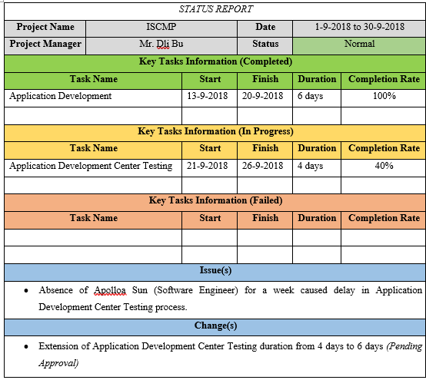

***TABLE 10.3.4: ISCMP Status Report Sample***

1. **Progress Report**

Unlike status report, progress report indicates **what has been accomplished** within the project team, with the amount of time mentioned to determine the period used to finish the tasks. It is usually adapted in cases where milestones are met for the project’s scopes. While not as complicated as status report, important information would be needed to convey about the project’s activities in the **monthly** format as shown, using ISCMP as an example of the case in ***TABLE 10.3.5***:

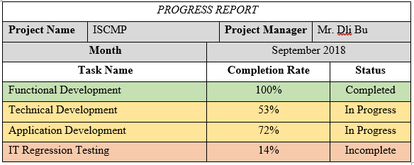

***TABLE 10.3.5: ISCMP Progress Report Sample***

1. **Forecast Report**

Based on the past experiences and trends, forecast would be made to **predict a project’s status and progress** to anticipate how long would it take to complete the project’s milestones. The reference would usually root from the similar projects that have been attempted at the pastimes. In the case of ISCMP scenario as in ***TABLE 10.3.6***, a **monthly** forecast report would be made to anticipate the priority of each tasks that should be given:

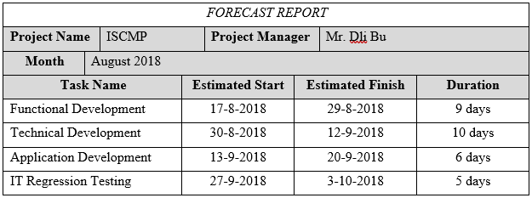***TABLE 10.3.6: ISCMP Forecast Report Sample***

**CONTROL COMMUNICATIONS**

After the communication methods have been implemented, the communication process in the project team would be constantly monitored and controlled to ensure that the requirements from the communications management plan are met.

With reference to the outputs from the planning and managing processes such as the project management plan, project communication system, data of work performance, and organizational process assets, the controlling process of the project team’s communication delivers the **information on work performance**, lists of **change requests**, and **updates** on **project management plan**, **project documents**, and **organizational process assets**. In this process, constant observation and monitoring is necessary to produce these outputs at designated intervals.

**Issue Log**

Issue log is a method often used to **identify the project’s issues** that are either resolved, or still ongoing. In this scenario, it could be used to **track any errors** that occurred in ISCMP, while presenting to the project managers and stakeholders on the project’s status even further (Marchewka, 2014).

While it is just a tracking of the project’s progress, it **contributes in meetings** among members of the ISCMP team and resolves **ISSUE NO. 6** as well. Issue log is, in this case, a list of occurring problems of the project that is required to be solved, and thus serves as a **clear guideline** to the project team staffs to **have immediate and precise understanding on the tasks** in which they need to take priority for. In a way, it contributes to a better alignment of tasks delegation for determining a more approachable Work Breakdown Structure. In short, a **regularly conducted meeting paired with effectively organized issue logs** would resolve the issue of decentralized Work Breakdown Structure.

In a section of Issue Log as shown in ***TABLE 10.3.7***, the issue’s index, with its description, would be mentioned with summary of the issue. Using **ISSUE NO.6** as the core of the issue, it is shown that the issue being the Work Breakdown Structure being done in separate instead of a centralized manner, and not reviewed at top of that.

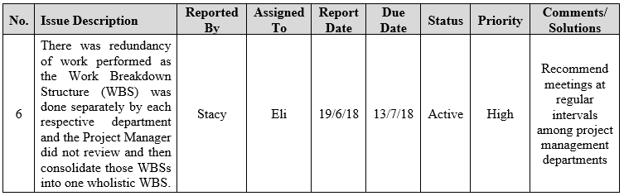***TABLE 10.3.7: Issue No. 6 Section of ISCMP Issue Log Sample***

The individual(s) who states the issue and the ones whom are directed with are mentioned in the Issue Log as well. This is to **ensure the clients related to the issue are properly addressed**. For this issue, the person who reports the issue would be a **representative from the project development team** (e.g. Software Engineers), with the placeholder name of Stacy; while the addressed individual would be the **Project Manager**, whose placeholder name is Eli.

The same concept is applied for the statement of report date and due date, to **indicate the time required to resolve the issue**, although usually by rough estimated for the issue’s manager. The report and due dates in this instance are based on the project’s pre-determined milestones, where the report date is **when the project has received approval** (19/6/18), and the due date being the time when the **project planning has completed** (13/7/18), the time when WBS must be finished and is set as the guideline for project execution.

The issue’s status **informs the clients if the issue has been resolved**, while the priority **shows the issue’s level of importance** compared to other issues, since a typical project would have multiple issues occurring at the same time intervals. The status could be identified in 2 main stages, where it could be already resolved (Closed), or **still ongoing and not resolved yet (Active)**. This issue takes place on the latter stage. The levels of importance, on the other hand, ranks the issues in 3 stages, as in not important (Low), somehow urgent (Medium), and **immediate emergency (High)**. This issue falls on the ‘High’ category as it must be resolved during the project’s planning phase.

The comments would normally be a **post script on sections required to be aware on the issue**, based on the client’s point of view. However, if resolved, its solutions would be written instead as a reference for solving other issues. In this case, since the issue is not yet resolved, **comments from the client’s side** on recommended actions would be noted down, as in *“recommend meetings at regular intervals among project management departments”.*

**Sample Issue Log**

An example of the issue log applicable in ISCMP is shown in the following table with appropriate issues as samples, as displayed in ***TABLE 10.3.8***:

|  |  |  |  |  |  |  |  |  |
| --- | --- | --- | --- | --- | --- | --- | --- | --- |
| **No.** | **Issue Description** | **Reported By** | **Assigned To** | **Report Date** | **Due Date** | **Status** | **Priority** | **Comments/ Solutions** |
| 1 | The steering committee (which consist of the board of directors, CEO and Senior Managers of the organization) do not recall of being presented the project feasibility study by the Project Sponsor or the Project Manager to them. | Condon | Eli | 10/6/18 | 13/7/18 | Active | High | The Senior Managers are still pending reply on contact info |
| 2 | The project approval was not formally documented. | Isa | Eli | 10/6/18 | 19/6/18 | Closed | High | Hired a new secretary |
| 3 | There is no evidence that a proper project management process was followed. | Shela | Hazel | 13/7/18 | 24/7/18 | Active | Low | Hired a new secretary, but still in training |
| 4 | The PC and server hardware technical specifications were constantly being changed to suit new or added requirements. | Lucie | Barr | 19/6/18 | 24/7/18 | Active | Medium | Barr is currently working on a list of approval for the project’s assets |
| 5 | Requirements keep coming in from users almost daily where the GITS-ADC Team Lead keeps on accepting them without hesitation. | Alvera | Hazel | 13/7/18 | 24/7/18 | Active | Medium | Hazel plans on making a new format on Change Approval Report |
| 6 | There was redundancy of work performed as the Work Breakdown Structure (WBS) was done separately by each respective department and the Project Manager did not review and then consolidate those WBSs into one wholistic WBS. | Stacy | Eli | 19/6/18 | 13/7/18 | Active | High | Recommend meetings at regular intervals among project management departments |
| 7 | Most of the team members have been focusing more on their daily operation support rather than tasks being assigned by the Project Manager or their respective Team Lead. | Abaya | Hazel | 24/7/18 | 20/9/18 | Active | Medium | Centralized WBS is still pending completion |
| 8 | Tasks are performed without prioritizing other dependent tasks | Keen | Hazel | 24/7/18 | 20/9/18 | Active | High | Centralized WBS is still pending completion |
| 9 | IT assets acquisition and spending were through PROC Manager with suppliers without going through a proper tendering process. | Langlois | Eli | 13/7/18 | 24/7/18 | Active | Medium | Hazel suggested approval from Barr for tendering processes |
| 10 | Purchasing of IT assets without a proper tendering process has led to overrun by budget. | Chante | Barr | 13/7/18 | 24/7/18 | Closed | Medium | Complied a proper Resource Cost Breakdown |
| 11 | The testing plan was not developed yet. | Nevilla | Hazel | 20/9/18 | 9/10/18 | Active | Low | Software development process pending approval before testing is verified |
| 12 | There was not even a clear designated sponsor (or sponsors) for the project. | Phan | Eli | 19/6/18 | 24/7/18 | Closed | Medium | Procurements were decided on contract-basis after make-buy analysis |
| 13 | There was no clear project organizational structure to manage the project. | Devon | Eli | 10/6/18 | 13/7/18 | Closed | High | Eli has created a new organizational structure upon arrival |
| 14 | The Project Manager’s authority was constantly overridden by the department head managers. | Tom | Hazel | 10/6/18 | 19/6/18 | Closed | Low | Eli has created a new organizational structure upon arrival |
| 15 | Technical skills were especially lacking in the network and security areas. | Tord | Hazel | 19/6/18 | 20/9/18 | Closed | High | HR promised and hired technical assistants on that field |
| 16 | There were no monitoring reports to review as none were prepared and formally documented. | Edd | Eli | 24/7/18 | 9/10/18 | Active | Low | Template for project reports (Status, Progress, Forecast) remained in progress |
| 17 | The risks associated with the project, although documented, had no detailed action plans and were not categorized in terms of impact or severity. | Matt | Eli | 13/7/18 | 9/10/18 | Active | Medium | The risks were to be announced among Senior Managers in meetings for expert judgements |
| 18 | The hardware and software delivery were still being negotiated with some potential vendors while there were only four (4) months to complete the project. | Djeeta | Barr | 19/6/18 | 13/7/18 | Active | Medium | Hazel and Barr needed to discuss on the cost and asset the project team provides initially |

***TABLE 10.3.8: ISCMP Issue Log Sample***

**CONCLUSION**

While communication among project team does not directly impact the project’s development in technical aspect, it is a lifelong factor that would determine cooperation between individuals where team-based projects would highly value for. With 3 of the issues regarding the factor of communication that occurred in ISCMP, the issues could be resolved by adapting the **communication requirement analysis** to understand the best communication medium for everyone; using **issue log**s as guidelines for discussion while conducting **meetings** among project management staffs on proper work schedule planning; and applying the use of **performance reporting** using uniform templates during project updates to ensure a smooth flow of discussions by having every stakeholder on the same page.

**LESSON LEARNED REPORT**

During the analysis of the issues by applying tools and techniques applicable to the solution of those issues, I have learnt the use of **communication requirement analysis** in the aspect of more effective information delivery to all project management team. The analysis could be carried out in multiple forms involving inspecting elements of communication methods, technologies and models to compile a communications management plan for effective communication method selection. In the meantime, the importance of **meetings** and **issue logs** are proven from its adaption to the completion of an approachable Work Breakdown Structure by setting up department-based meetings in regular time intervals, all in the meantime using issue logs as a guidance for arranging all issue’s and task’s priority and status. As for the application on **performance reporting**, the creations of status report, progress report, and forecast report’s templates have been learnt to provide a clear routine check on all department’s progress while ensuring the project team wouldn’t go sidetracked from the low-priority tasks.

## 10.4 Risk Management **[Yeo Zhi Yin, TP035402]**

Project risk is uncertain or random events which has positive or negative effect on project objectives and can occur anytime. Risk can have one or more causes and cause multiple impacts on the project. It can be avoided or mitigated by planning or through pre-emptive action. (Sharma, 2013)

Risk management holds as an important role in IT project when it comes in controlling the quality of the product delivered by the project team. Improper risk management plan will cause a project to fail. Risk management is one of the knowledge areas that required in IT project.

Risk management is a process consist of risk management planning, identification, analysis, response planning and project risk controlling. Leader/Project manager of the team uses this technique to reduce the negative risks and brings benefits of the events that occurred during the project duration.

There are few procedures that can assist the project manager on managing the negative risks during the project which are the following (Institude, 2013):

* *Plan Risk Management*
* *Identify Risks*
* *Perform Qualitative Risk Analysis*
* *Perform Quantitative Risk Analysis*
* *Plan Risk Responses*
* *Control/Monitoring Risks*

With these processes, the team will be able to response with appropriate action the reduce the impact and effect of the risk or even gain positive effect from the risk. Risk should be managed throughout the whole project duration and expecting some unexpected events or problems to be happened during the execution of the project. A project comes with the risk start from initiating phase of project. A calm mind-set or experienced project manager will be more ready when risks happen. Proper risk management planning helps the project progress with less chance of getting negative effects by the risk occurred during the project life time.

**Plan Risk Management**

Project team need to come up with plans that can estimate the possible risks that will be faced by the team during the project. Failure of the previous team that was handling the project would be a good example for references for the current team to develop a risk management plan. Risk management plan consist of how the risk management activities will be carried by the project team. Risk management plan includes few components that will help on identifying risks of a project which are the following (Institude, 2013):

* *Methodology*
* *Roles and responsibilities*
* *Timing*
* *Probability*
* *Impact matrix*

The project management has provided the baseline of current situation of the project such as budget, time management, module, human resources. All these resources are needed to be counted in the risk management planning. Project charter provides high-level risk, risk description and high-level budget for the risk management planning. Factors like enterprise environmental, organizational process and stakeholders are needed to be considered in the planning of risk management. (Institude, 2013)

Delphi technique is used on for analysis of inputs of the resources given to the risk management planning as it is the most suitable technique to use. With the Delphi technique we can conclude some suitable resolutions for current situation of the project. Expert judgements from specific fields are used to ensure a well-planned risk management developed by the project team. (Satish, 2015)

Meeting with stakeholders should be conducted frequently to discuss and for them to catch up the progress of the project and issues they are facing in the project.

Risk management team of the project will be using methodology to identify and analyze the risks that will be faced by the project team. Risk manager will have to consider the financial impacts of each risks, opportunities, budget and risk control method.

**Roles & Responsibilities**

|  |  |
| --- | --- |
| Position | Responsibilities |
| Project Manager | Risk Planning |
| Risk control |
| Attend risk meeting and lead the team |
| Financial Manager | Submit financial report to project manager |
| Calculate the risk management cost |
| Procurement Manager | Ensure the tendering process goes smoothly |
| Confirmation on the contracts with vendors |
| Human Resource Manager | Maintains resource power |
| Team Leader | Monitor team members |
| Ensure team members progress speed |
| Submit progress report to project manager |

Project manager should have the highest authority to the project including the control of budget, human resources like organizing man power, making decision for the project team etc. Managers of the departments would have to manage what their department was supposed to do. Other managers from different department should not have higher authority than the project manager. List of responsibilities of respective departments should be stated clearly. Managers from every department should report their progress and report to the project manager frequently to keep up to date.

**Risk Breakdown Structure**

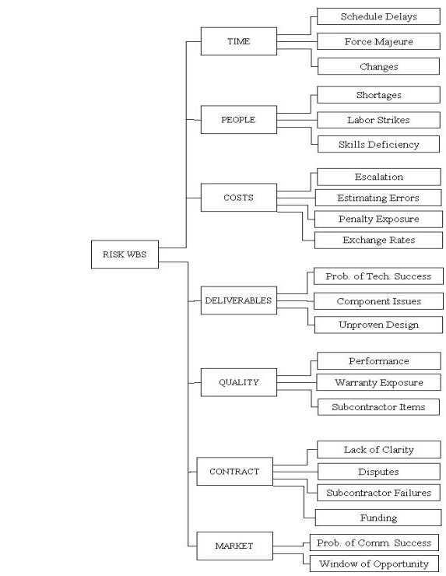

Figure 1https://project-management.com/understanding-the-risk-breakdown-structure-rbs/

**Risk Probability & Impact**

Risk probability are the chances which a risk may occur during the execution of a project.

It is measured by the method of percentage in the probability multiply by impact which is P x I matrix used in the qualitative analysis of risks. Risk impact is the severity level of the impact of the risk to the project. Budget cost, staff health and safety and some critical factor are considered in risk and impact. It is not possible to estimate when will risk happen or how it will happen but by doing analysis on the risks and come out with solutions can help to mitigate the risks or avoid them. Probability x Impact Matrix is used to analyses the risk and categories them into 4 level which is the following (Mind Tools Content Team, 2018).

* *- Low impact/low probability*
* *- Low impact/high probability*
* *- High impact/low probability*
* *- High impact/high probability*

Risk management process will be done by the risk management monthly to update the risk register since the project has short duration. Risk manager will have to re-asses every risk on the risk register to adjust the solution and update them.

**Identify Risk**

Delphi technique and interview are used to identify the risks which may happen during the duration of project.

Delphi technique is a forecasting or estimating method based on a discussion by a group of experts (J, 2018). The group are asked to anonymously answer a survey and provide feedback on each other’s answers. The process repeats itself and aim to come up with concrete solutions.

Interviews are conducted between project members, related fields experts and stakeholders to understand what the status of the project is and analyze the situation. Questions will be asked and answered by the interviewee during the interview. The outcome of the interview will be analyzed and added to the risk register.

Situation from the previous team will be analyzed too and find out what was the problem occurred when they were handling the project.

**Risk Register**

Risk register is a documented list of risks that has been identified by the risk manager, It includes potential risks and identified risks. The key components of a risk register are stated below:

* Description of the Risk
* Risk Type (business, project, stage)
* Probability of risk occurring
* Impact of risk
* Risk owner
* Root cause
* Status

Risk register requires opinions from every departments including stakeholders of the system. It must provide framework to the team on how to solve the risk or avoid the risk. Risk register should be reviewed by stakeholders to let them have knowledge on what risks they might face and be prepared for it. If there is any risk that is not identified, they will provide information on the unidentified risk.

**Qualitative Risk Analysis**

Qualitative risk analysis is to identify the severity of the risk in the project by combining the probability and impact of the risk. The purpose of doing this analysis is to allow the control of the risk based of its severity. Risk manager have to come out with a good strategy that can mitigate or avoid the risks during the project.

Probability x Impact matrix will be used in the qualitative risks in the risk register. Risk are assessed with their probability of occurring and the impact of the risk during the project.

|  |  |  |  |  |  |  |
| --- | --- | --- | --- | --- | --- | --- |
| Risk Matrix | | Impact | | | | |
| 1 | 2 | 3 | 4 | 5 |
| Probability | 5 | 5 | 10 | 15 | 20 | 25 |
| 4 | 4 | 8 | 12 | 16 | 20 |
| 3 | 3 | 6 | 9 | 12 | 15 |
| 2 | 2 | 4 | 6 | 8 | 10 |
| 1 | 1 | 2 | 3 | 4 | 5 |

Table 1 Risk Assessment Scoring P x I

The probability of risk occur are scaled by the percentage of the occurrence of event where the impact is scaled by the percentage of the impact that will affect the project. The risks are separated into 4 type, the risk under green zone represents marginal risk, blue zone represents minor risk, yellow zone represents moderate risk, brown zone represents major risk and red zone represents critical risk.

**Quantitative Risk Analysis**

Expected Monetary Value (EMV) analysis is the calculation of expected monetary value of a decision given by the probability and the impact of a risk occurred during the project. It is used to calculate the losses or profit by using a table or decision tree diagram. EMV is used in quantitative risk analysis to calculate the cost of an action to address the risks in risk registers. The method to calculate EMV is by using probability multiply by impact.

**Risk Responses**

Each negative risk and positive risk has 4 types of risk response so there are a total of 8 types of risk response.

**Negative Risk**

* **Avoid** – Changing the project plan to eliminate the risk to protect the project objectives from its impact.
* **Transfer** – Transfer the risk to third party who will carry the risk impact.
* **Mitigate** – Reduce the probability of risk occur and impact to within an acceptable level.
* **Accept** – Do not do anything until the risk happens.

**Positive Risk**

* **Exploit** – Ensure the risk happens by eliminating the uncertainty.
* **Enhance** – Increase the probability of its occurrence or the impact.
* **Share** – Allocate the ownership to a third party who has higher chance of achieving better result.
* **Accept** – Accept the positive effect but doesn’t commit too much on the risk.

**Risks Control**

Risks identified needs to be controlled by implementing risk response plan. Risk register needs to be updated frequently. New risks which might be threating the project should be identified and prepare risk responses plan for it.

**Risk Register**

|  |  |  |  |  |  |  |  |  |  |  |  |  |  |
| --- | --- | --- | --- | --- | --- | --- | --- | --- | --- | --- | --- | --- | --- |
| Risk ID | Risk Categorization | Risk | Cause | Trigger | Probability | Impact | Monetary Value | Priority | EMV | Response Strategy | Potential Response | Status | Risk Owner |
| 1 | Project Risk | The steering committee do not recall of being presented the project feasibility study by the Project Sponsor or the Project Manager to them. | Miscommunication between project team and steering committee | Steering committee questioning about the budget ,technical and operation issue | 20% | 2 | -$7,000 | 4 | -$1,400 | Mitigate | Present project feasibility study to the steering committee | Open | Project Manager |
| 2 | Project Risk | The project approval was not formally documented. | Packed schedule disallow team members to do the documentation | Documentation is not prepared | 70% | 3 | -$10,000 | 21 | -$7,000 | Mitigate | Have meeting between steering committee to get it formal approval documented | Open | Project Manager |
| 3 | Project Risk | There is no evidence that a proper project management process was followed. | Project manager lacking of managing skill | Documentation and WBS is not done | 30% | 2 | -$7,000 | 6 | -$2,100 | Mitigate | Get WBS up to date | Open | Project Manager |
| 4 | Technical Risk | The PC and server hardware technical specifications were constantly being changed to suit new or added requirements. | Acceptance of additional requirement of system without consideration of the limit | Lack of advanced hardware to support | 30% | 3 | -$10,000 | 9 | -$3,000 | Avoid | Cancel some additional requirement of the system | Open | Business Analyst / Developer Team |
| 5 | Technical Risk | Requirements keep coming in from users almost daily where the GITS-ADC Team Lead keeps on accepting them without hesitation. | Miscommunication between Business Analyst and Developing team | Packed modules causing system cannot finish in time | 30% | 3 | -$15,000.00 | 9 | -$4,500 | Avoid | Cancel some additional requirement of the system | Open | Business Analyst / Developer Team |
| 6 | Schedule Risk | There was redundancy of work performed as the Work Breakdown Structure (WBS) was done separately by each respective department and the Project Manager did not review and then consolidate those WBSs into one holistic WBS. | Miscommunicate between department leads | Departments does not centralize their management | 20% | 4 | -$10,000 | 8 | -$2,000 | Avoid | Conduct review on WBS | Open | Department Leads |
| 7 | Schedule Risk | Most of the team members have been focusing more on their daily operation support rather than tasks being assigned by the Project Manager or their respective Team Lead. | Improper communication method was used to communicate between team members and team lead | Slower progress of the project | 10% | 3 | -$5,000 | 3 | -$500 | Accept | Conduct meeting with discussion on the issues | Open | Team Lead / Project Manager |
| 8 | Schedule Risk | tasks are performed without prioritizing other dependent tasks. | WBS not well scheduled, wrong tasks was prioritized | There is no progress on critical task | 10% | 2 | -$5,000 | 2 | -$500 | Mitigate | Scrum meeting for the tracking on the high priority tasks | Open | Scrum Master |
| 9 | Financial Risk | IT assets acquisition and spending were through PROC Manager with suppliers without going through a proper tendering process. | PROC Manager might be corrupted | PROC manager does not have evidence to show that tendering process is done in a legit way | 10% | 3 | -$10,000 | 3 | -$1,000 | Accept | Request PROC Manager to deal with the supplies in proper tendering process | Open | PROC Manager |
| 10 | Financial Risk | purchasing of IT assets without a proper tendering process has led to overrun by budget. | Lack of comparison between supplier by PROC Manager | Budget are allocated on some unnecessary stuff | 20% | 2 | -$15,000 | 4 | -$3,000 | Avoid | Reduce cost of incoming asserts | Open | PROC Manager |
| 11 | Schedule Risk | the testing plan was not developed yet. | Inexperienced software tester | Quality Assurance Team has slower progress | 40% | 3 | -$10,000 | 12 | -$4,000 | Mitigate | Track and make sure team members finish task on time | Open | Quality Assurance Team Lead |
| 12 | Financial Risk | there was not even a clear designated sponsor (or sponsors) for the project. | Budget planning are poorly documented | Sponsors are not agreeing with the project | 20% | 3 | -$5,000 | 6 | -$1,000 | Avoid | Prepare better proposal or look for other sponsors | Open | Financial Manager |
| 13 | Project Risk | there was no clear project organizational structure to manage the project. | Project manager does not develop an organization structure | Department leads has overridden other department lead’s authority | 30% | 4 | -$20,000 | 12 | -$6,000 | Avoid | Develop an organizational structure | Open | Steering Committee |
| 14 | Project Risk | the Project Manager’s authority was constantly overridden by the department head /managers. | Organization structure is not clearly stated and misunderstanding on authority of department leads | Project manager do not have the authority that match his position | 30% | 4 | -$20,000 | 12 | -$6,000 | Avoid | Let department leas know their authority | Open | Steering Committee |
| 15 | Technical Risk | technical skills were especially lacking in the network and security areas. | Developer team lack of experience | System get attacked by anonymous | 20% | 4 | -$10,000 | 8 | -$2,000 | Transfer | Outsource modules to vendors | Open | HR Department |
| 16 | Project Risk | there were no monitoring reports to review as none were prepared and formally documented. | Team leads did not properly list or inform to the project manager | Lack of documents that supports monitoring job | 30% | 3 | -$5,000 | 9 | -$1,500 | Avoid | Team leads are required to prepare monitoring reports | Open | Project Manager |
| 17 | Project Risk | the risks associated with the project, although documented, had no detailed action plans and were not categorized in terms of impact or severity. | Risk management are not well planned | Team members do not have solution to solve the problem when risks occur | 50% | 5 | -$15,000 | 25 | -$7,500 | Mitigate | Revise the risk register and implement risk response plan | Open | Project Manager |
| 18 | Technical Risk | the hardware and software delivery was still being negotiated with some potential vendors while there were only four (4) months to complete the project. | Bad negotiation skills from PROC manager | Unlicensed product | 20% | 3 | -$5,000 | 6 | -$1,000 | Transfer | Conduct negotiation with the hardware and software vendors | Open | PROC Manager |

**Conclusion**

Risk management is essential for the project team during a project. Proper risk management can lead to success of a project. Risk management should be done properly and well planned to increase the success rate of a project. Risk management requires sources from every department including the stakeholders of the system.

**Lesson Learned Report**

During the analysis of the issues by applying tools and techniques applicable to the solution of those issues, I have learned that risk management is an important element for a project as risk register can prevent a lot of unnecessary risk that might cost the project to fail or cause loses in financial and reputation. Risk register must be well planned to avoid or prepare for unexpected risk for team to overcome the tricky situation.

# References

1. Atkinson, R., 1999. Project management: cost, time and quality, two best guesses and a phenomenon, its time to accept other success criteria. *International journal of project management,,* 17(6), pp. 337-342.
2. Bullwinkle, K., 2016. *Teams: Rewards and Recognition.* [Online]   
   Available at: https://www.talentgear.com/learn/october-2016/team-recognition/  
   [Accessed 28 August 2018].
3. Cockburn, A., 2000. Selecting a project's methodology. *IEEE software,* 17(4), pp. 64-71.
4. Cooper, B. F. et al., 2010. Benchmarking cloud serving systems with YCSB. *Proceedings of the 1st ACM symposium on Cloud computing,* pp. 143-154.
5. David L. Wilemon, H. J. T., 1983. Team building in project management: Secret Ingredients for Blending American and Japanese Management Technology. *Project Management Quarterly,* 14(2), p. 73–81.
6. Dwevedi, P., 2017. *Recognition and Reward System in the Project Management.* [Online]   
   Available at: https://www.simplilearn.com/recognition-reward-system-project-management-article  
   [Accessed 28 August 2018].
7. España, S., González, A. & Pastor, Ó., 2009. Communication Analysis: a requirements engineering method for information systems. *International Conference on Advanced Information Systems Engineering,* pp. 530-545.
8. Esther, S. et al., 2009. Role understanding and effective communication as core competencies for collaborative practice. *Journal of interprofessional care,* 23(1), pp. 41-51.
9. Fichtner, C., 2016. *The Project Manager’s Essential Interpersonal Skills.* [Online]   
   Available at: https://www.projectmanagement.com/blog-post/21642/PMP-Exam-Tip--The-Project-Manager-s-Essential-Interpersonal-Skills  
   [Accessed 31 August 2018].
10. Fuller, M. A., Valacich, J. S., George, J. F. & Schneider, C., 2017. *Information Systems Project Management: A Process and Team Approach.* 1.1 ed. s.l.:Prospect Press.
11. Gehring, D. R., 2007. Applying traits theory of leadership to project management. *Project Management Journal,* 38(1), p. 44–54.
12. Gyung-Jin, P., 2007. Design of experiments. *Analytic Methods for Design Practice,* pp. 309-391.
13. Heathfield, S. M., 2017. *Beyond Hiring and Firing: What is HR Management.* [Online]   
    Available at: https://www.thebalancecareers.com/what-is-human-resource-management-1918143  
    [Accessed 29 August 2018].
14. Institude, P. M., 2013. *A Guide to the Project Management Body of Knowledge.* 5th ed. Newtown Square: Project Management Institute.
15. J, A., 2018. *The Delphi Technique: Definition & Example.* [Online]   
    Available at: https://study.com/academy/lesson/the-delphi-technique-definition-example.html  
    [Accessed 26 August 2018].
16. Juneja, P., 2018. *What is Human Resource Planning.* [Online]   
    Available at: https://www.managementstudyguide.com/human-resource-planning.htm  
    [Accessed 26 August 2018].
17. Kerzner, H. & Kerzner, H., 2017. *Project management: a systems approach to planning, scheduling, and controlling.* s.l.:John Wiley & Sons.
18. Kima, D.-Y., Kumar, V. & Kumar, U., 2012. Relationship between quality management practices and innovation. *Journal of operations management,* 30(4), pp. 295-315.
19. Larson, E. & Gray, C., 2013. *A Guide to the Project Management Body of Knowledge: PMBOK (®) Guide.* 5 ed. Pennsylvania: Project Management Institute.
20. Learn Certification, 2015. *Acquire Project Team - Tools and Techniques.* [Online]   
    Available at: http://www.learncertification.com/study-material/acquire-project-team-tools-and-techniques  
    [Accessed 27 August 2018].
21. Lewis, R. P., Igict, P. & Zhou, Z., 2009. Assessment of communication methods for smart electricity metering in the UK. *Sustainable Alternative Energy (SAE), 2009 IEEE PES/IAS Conference,* pp. 1-4.
22. Marchewka, J. T., 2014. *Information technology project management.* 5 ed. Minnesota: Schwalbe Publishing.
23. Mark, 2014. *contactzilla: 5 Psychological Theories of Motivation to Increase Productivity.* [Online]   
    Available at: https://contactzilla.com/blog/5-psychological-theories-motivation-increase-productivity/  
    [Accessed 26 August 2018].
24. Martinez, G. D., McKay, J., Farmer, B. & Scott, P., 2017. Comparison of statistical sampling methods with ScannerBit, the GAMBIT scanning module. *The European Physical Journal,* 77(11), p. 761.
25. McQuail, D. & Windahl, S., 2015. *Communication models for the study of mass communications.* s.l.:Routledge.
26. Mind Tools Content Team, 2018. *Risk Impact/Probability Chart Learning to Prioritize Risks.* [Online]   
    Available at: https://www.mindtools.com/pages/article/newPPM_78.htm  
    [Accessed 26 August 2018].
27. MindTools, 2016. *Forming, Storming, Norming, and Performing.* [Online]   
    Available at: https://www.mindtools.com/pages/article/newLDR_86.htm  
    [Accessed 28 August 2018].
28. Morey, J. N. et al., 2013. Young adults’ use of communication technology within their romantic relationships and associations with attachment style.. *Computers in Human Behavior,* 29(4), pp. 1771-1778.
29. Mullins, L., 2010. *Management and Organisational Behaviour.* Ninth ed. Harlow: Pearson Higher Education.
30. My Management Guide, 2018. *Project Team Acquiring.* [Online]   
    Available at: https://mymanagementguide.com/guidelines/project-management/hr-management/project-team-acquiring/  
    [Accessed 26 August 2018].
31. My Management Guide, 2018. *Project Team Developing.* [Online]   
    Available at: https://mymanagementguide.com/guidelines/project-management/hr-management/project-team-developing/  
    [Accessed 26 August 2018].
32. My Management Guide, 2018. *Project Team Managing.* [Online]   
    Available at: https://mymanagementguide.com/guidelines/project-management/hr-management/project-team-managing/  
    [Accessed 26 August 2018].
33. Neham, 2014. *Team Reviews vs. Appraisals.* [Online]   
    Available at: http://forum.izenbridge.com/viewtopic.php?t=1541  
    [Accessed 30 August 2018].
34. Papa, N., 2017. *bizfluent: Motivation Management Theories.* [Online]   
    Available at: https://bizfluent.com/about-7239234-motivation-management-theories.html  
    [Accessed 26 August 2018].
35. Pradip, 2017. *Interpersonal Skills of a Project Manager.* [Online]   
    Available at: https://www.simplilearn.com/project-manager-interpersonal-skills-article  
    [Accessed 31 August 2018].
36. Project Management Institute, 2004. *A Guide to the Project Management Body of Knowledge.* Third ed. Newtown Square: Project Management Institute, Inc..
37. Project Management Institute, 2013. *A Guide to the Project Management Body of Knowledge.* Fifth ed. Newtown Square: Project Management Institute, Inc..
38. Project Management Institute, 2017. *A Guide to the Project Management Body of Knowledge.* Sixth ed. Newtown Square: Project Management Institute, Inc..
39. RFFlow Electronics, 2016. *Project Organization Chart.* [Online]   
    Available at: www.rff.com/project_orgchart.php  
    [Accessed 21 August 2018].
40. S. Balaji, M. M., 2012. Waterfall vs. V-Model vs. Agile: A comparative study on SDLC. *International Journal of Information Technology and Business Management,* 2(1), pp. 26-30.
41. Satish, 2015. *A Tool Everyone In Project Management Should Be Using – Expert Judgement.* [Online]   
    Available at: https://www.apnacourse.com/blogs/expert-judgement-project-tool/  
    [Accessed 23 August 2018].
42. Sharma, R., 2013. *Reacting to Negative Risks in Risk Management Strategies.* [Online]   
    Available at: https://www.brighthubpm.com/risk-management/48016-responding-to-negative-risks-in-risk-management-strategies/  
    [Accessed 25 August 2018].
43. Soković, M., Jovanović, J., Krivokapić, Z. & Vujović, A., 2009. Basic quality tools in continuous improvement process. *Journal of Mechanical Engineering,* 55(5), pp. 1-9.
44. Swarthout, D., 2015. *AdjourningStage of Group Development: Definition & Explanation.* [Online]   
    Available at: https://study.com/academy/lesson/adjourning-stage-of-group-development-definition-lesson-quiz.html  
    [Accessed 28 August 2018].
45. Taylor, J. K., 2018. *Quality assurance of chemical measurements.* Routledge: Lewis Publishers.
46. Tooley, S., Hooks, J. & Basnan, N., 2010. Performance reporting by Malaysian local authorities: identifying stakeholder needs. *Financial Accountability & Management,* 26(2), pp. 103-133.
47. Vergidis, K., Tiwari, A. & Majeed, B., 2008. Business Process Analysis and Optimization: Beyond Reengineering. *IEEE Transactions on Systems, Man, and Cybernetics, Part C (Applications and Reviews),* 38(1), pp. 69-82.
48. Wandersman, A., Chien, V. & Katz, J., 2012. Toward an evidence-based system for innovation support for implementing innovations with quality: tools, training, technical assistance, and quality assurance/quality improvement. *American journal of community psychology,* 50(3-4), pp. 445-459.